

**Cloud Computing**

**Activity 19**

**CS5002**

**Name-Sheikh M Tadeeb**  **Enrolment ID-AU19B1014**

Bachelor of Technology

(2021 – 22)

* **Problem Statement:**

1. Create a LAMP server and capture all the screens for the configuration.
2. Create a User-data script to automate this and share its images as well.

* **Theory:**

**Brief:**

LAMP stands for Linux, Apache, MySQL, and PHP. Together, they provide a proven set of software for delivering high-performance web applications and as it contains PHP it works with Apache to help us create dynamic web pages as well.

**Architecture:**

LAMP has a classic layered architecture, with Linux at the lowest level. The next layer is Apache and MySQL, followed by PHP. Although PHP is nominally at the top or presentation layer, the PHP component sits inside Apache.

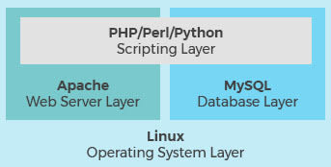

* **Preparing the LAMP server:**

**Step1)** Launching a new instance using Amazon Linux 2 with security group allowing SSH (port 22), HTTP (port 80), and HTTPS (port 443) connections.

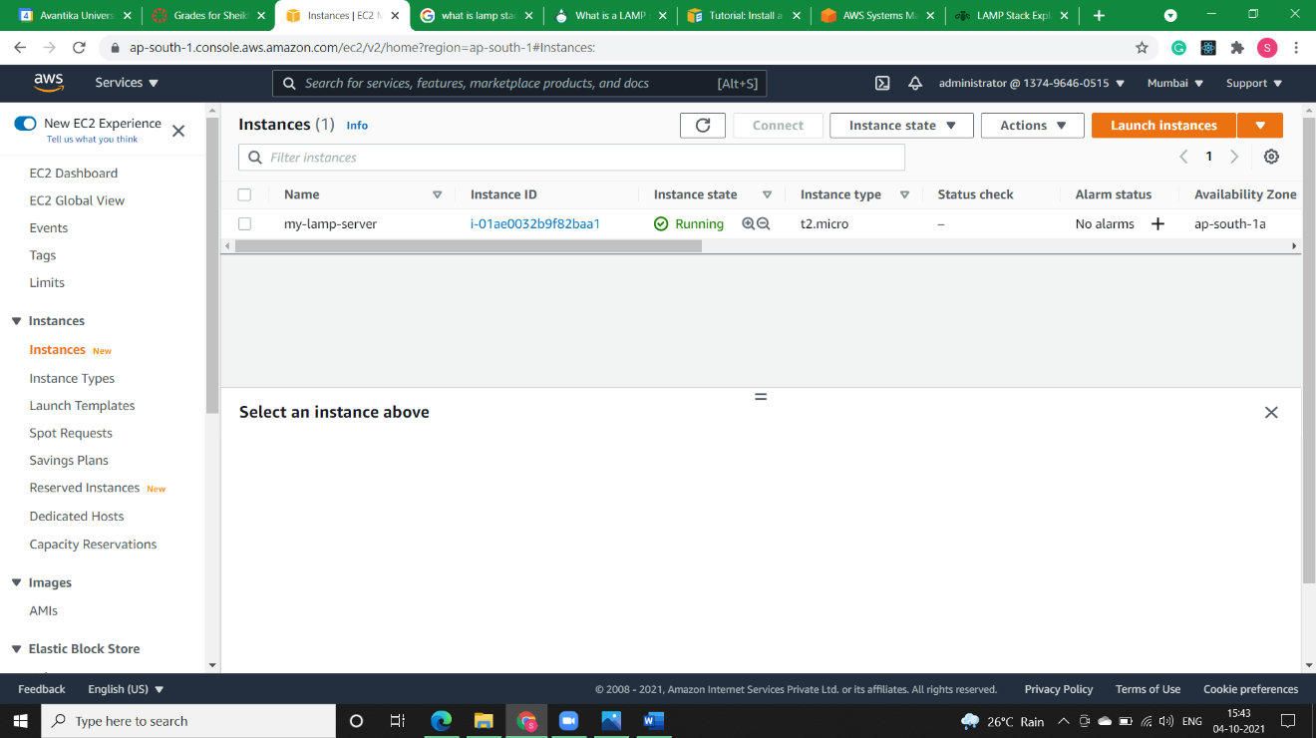

**Step2)** Opening putty to check whether we are connected to our instance or not.

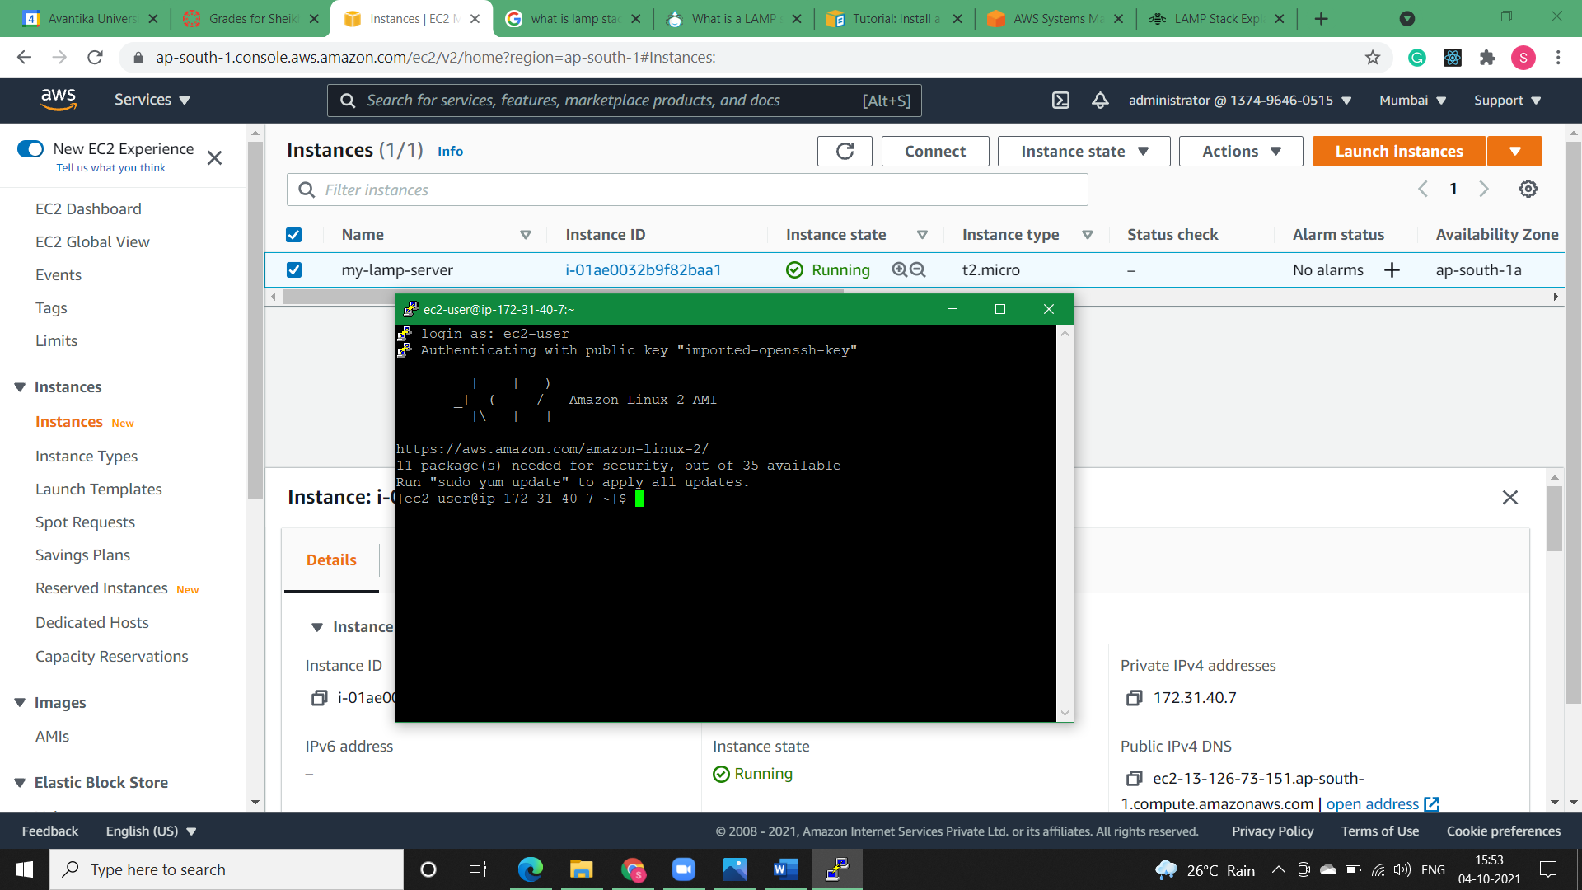

**Step3)** To ensure that all of your software packages are up to date, perform a quick software update on your instance. This process may take a few minutes, but it is important to make sure that you have the latest security updates and bug fixes.

The -y option installs the updates without asking for confirmation. If you would like to examine the updates before installing, you can omit this option

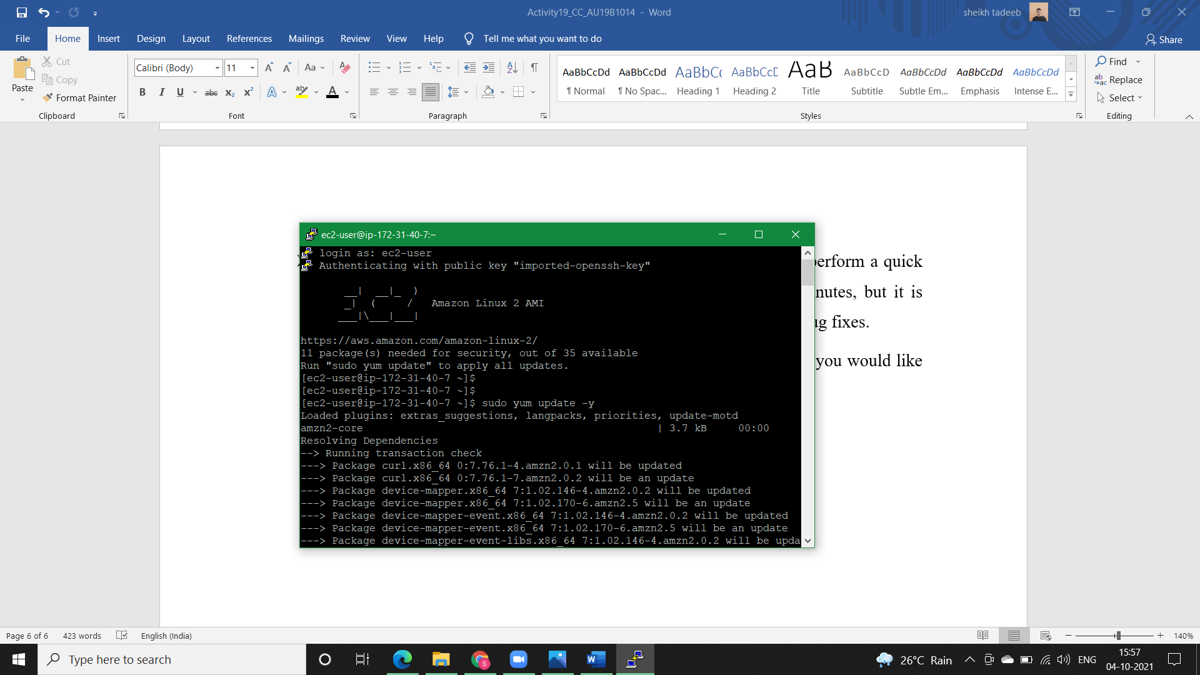

**Step4)** Install the lamp-mariadb10.2-php7.2 and php7.2 Amazon Linux Extras repositories to get the latest versions of the LAMP MariaDB and PHP packages for Amazon Linux 2.

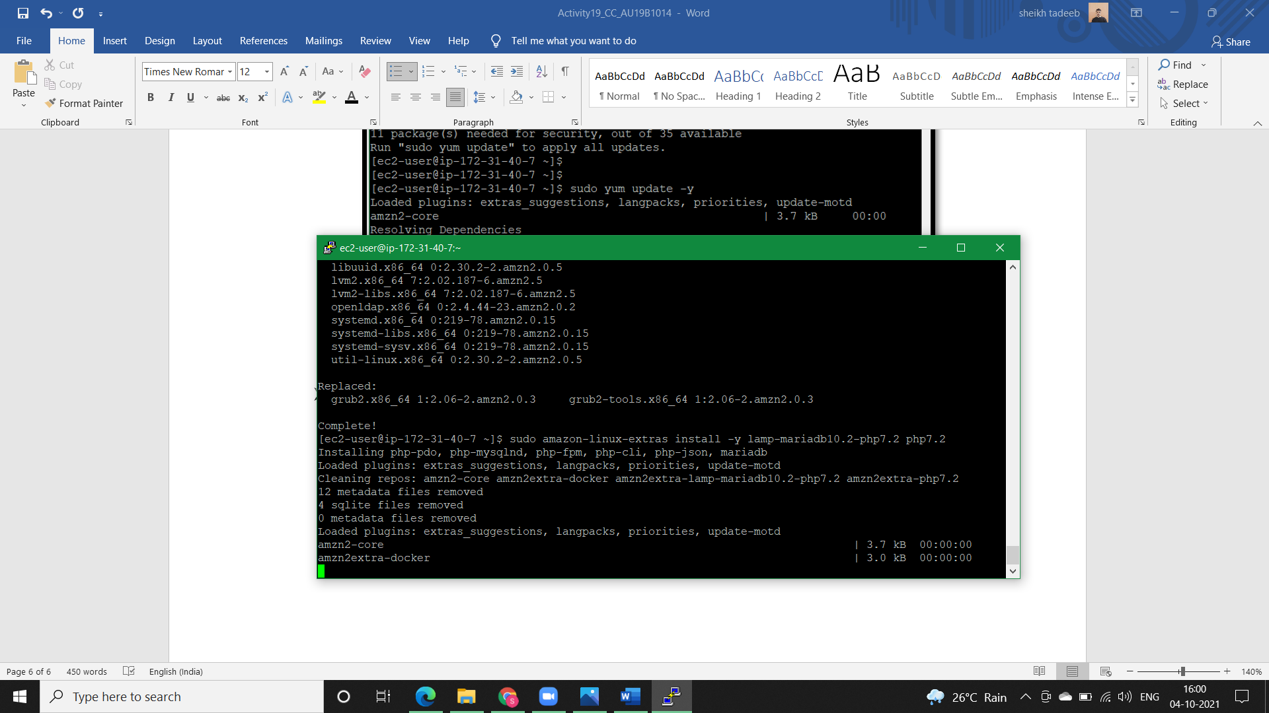

**Step5)** We can check information about our instance using system-release.

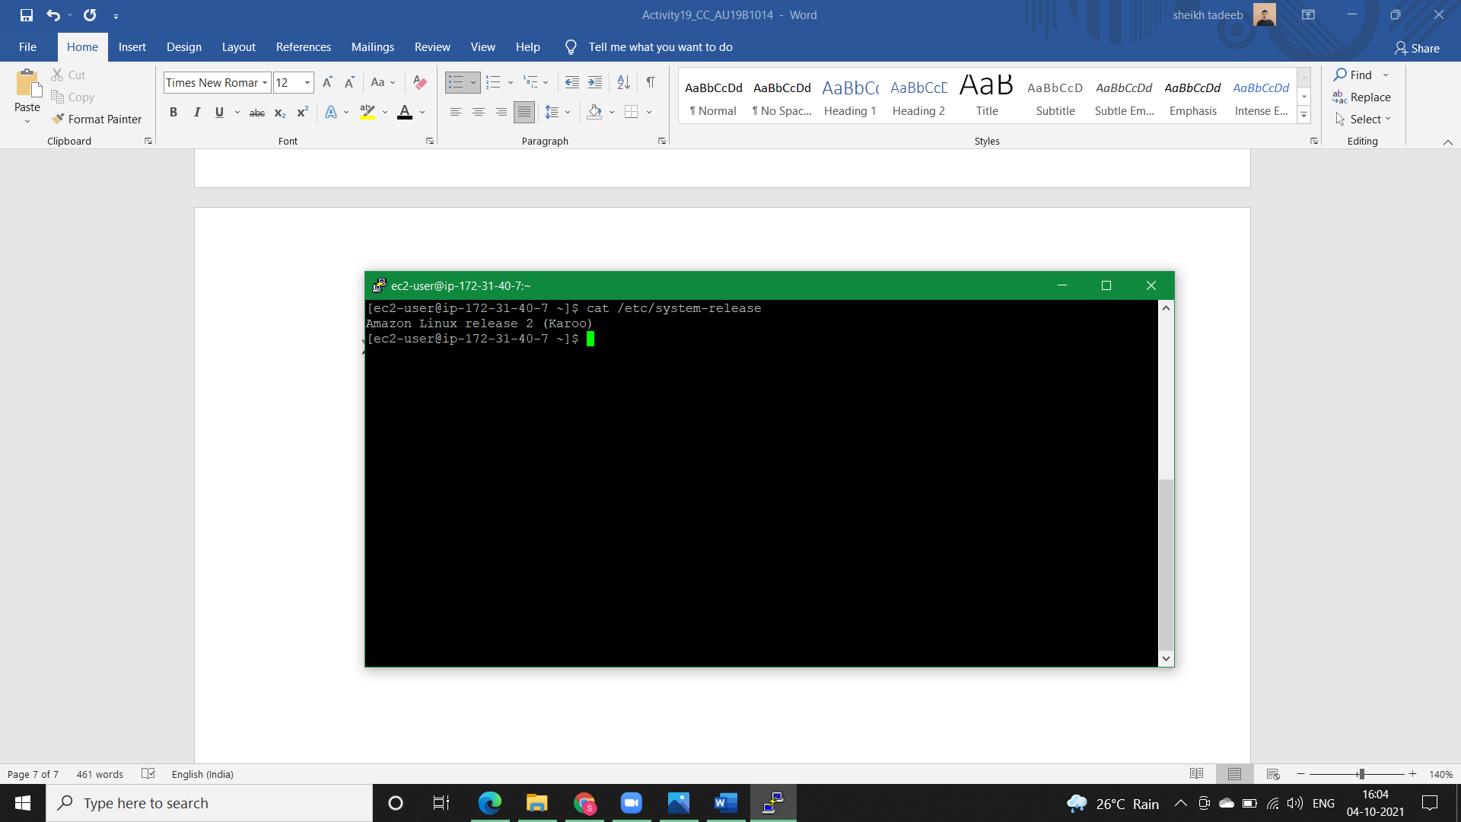

**Step6)** Now that your instance is current, you can install the Apache web server, MariaDB, and PHP software packages.

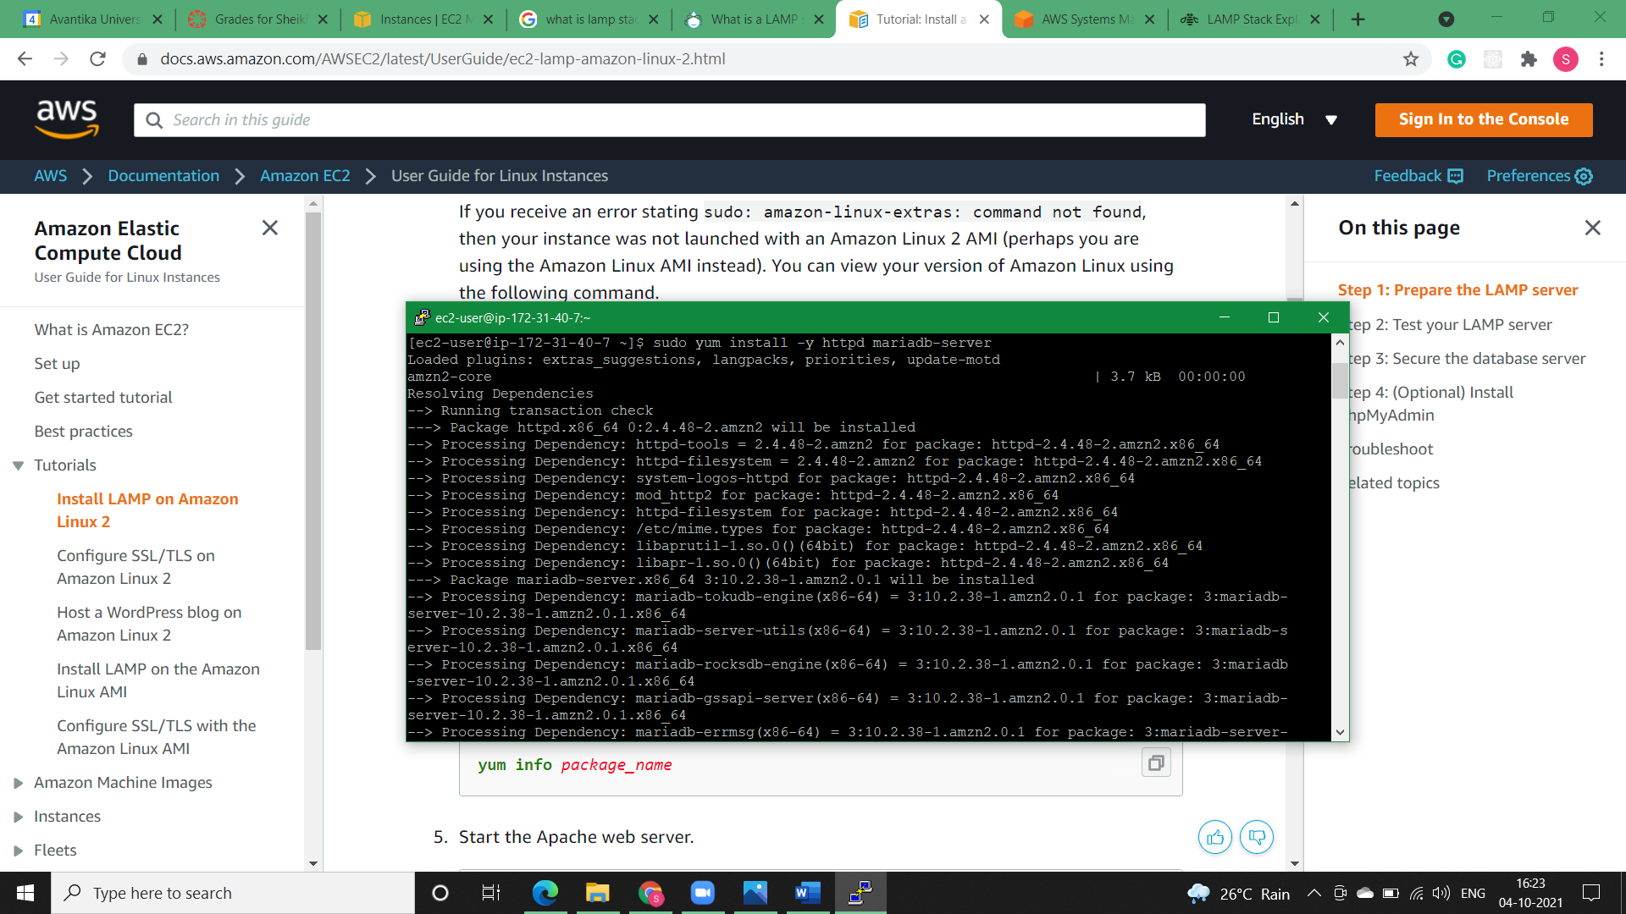

**Step7)** Start the Apache web server and check its status.

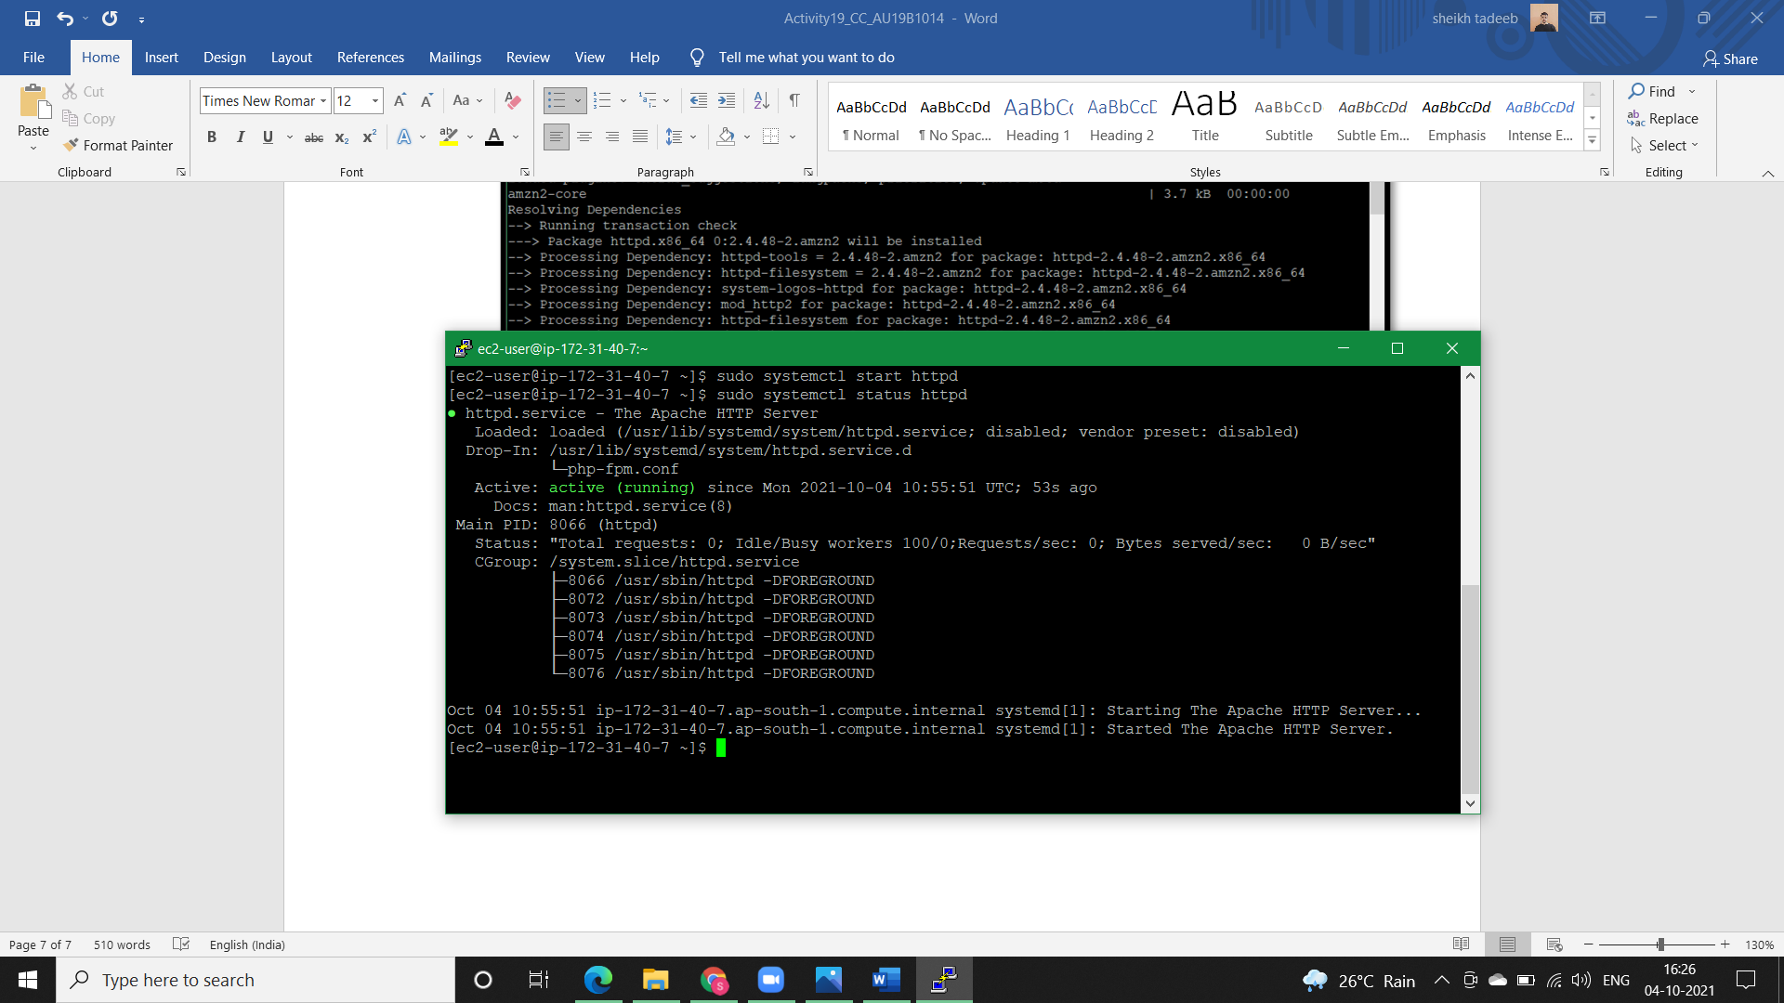

**Step8)** Use the *systemctl* command to configure the Apache web server to start at each system boot and check whether httpd is running or not.

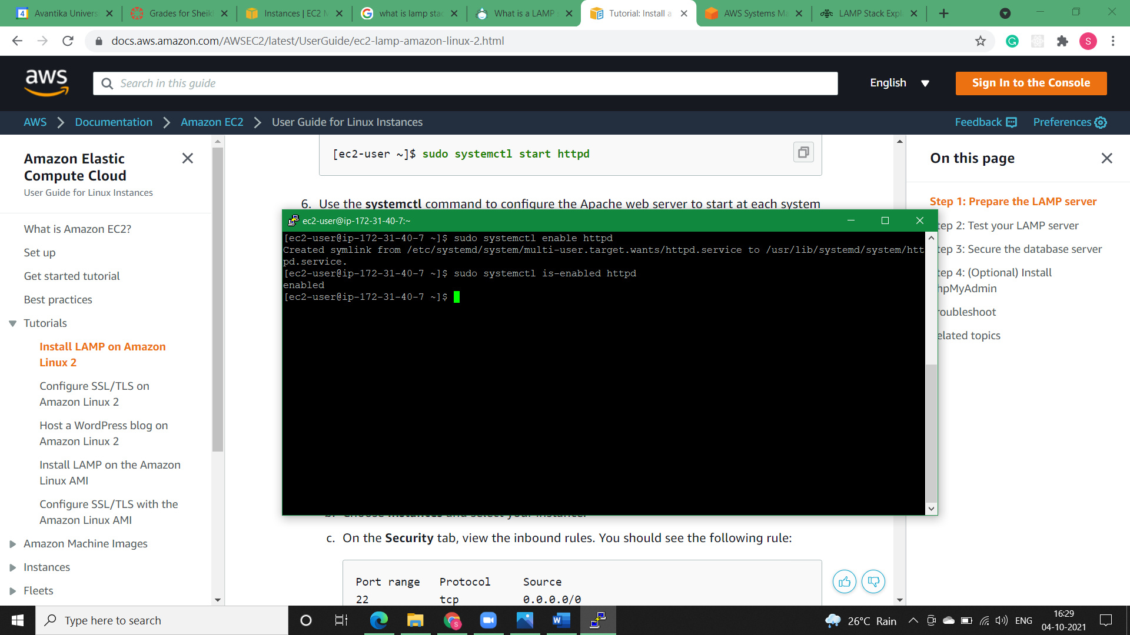

**Step9)** Test our web server. In a web browser, type the public DNS address (or the public IP address) of our instance. If there is no content in /var/www/html, we should see the Apache test page. We can get the public DNS for our instance using the Amazon EC2 console (check the Public DNS column; if this column is hidden, choose Show/Hide Columns (the gear-shaped icon) and choose Public DNS).

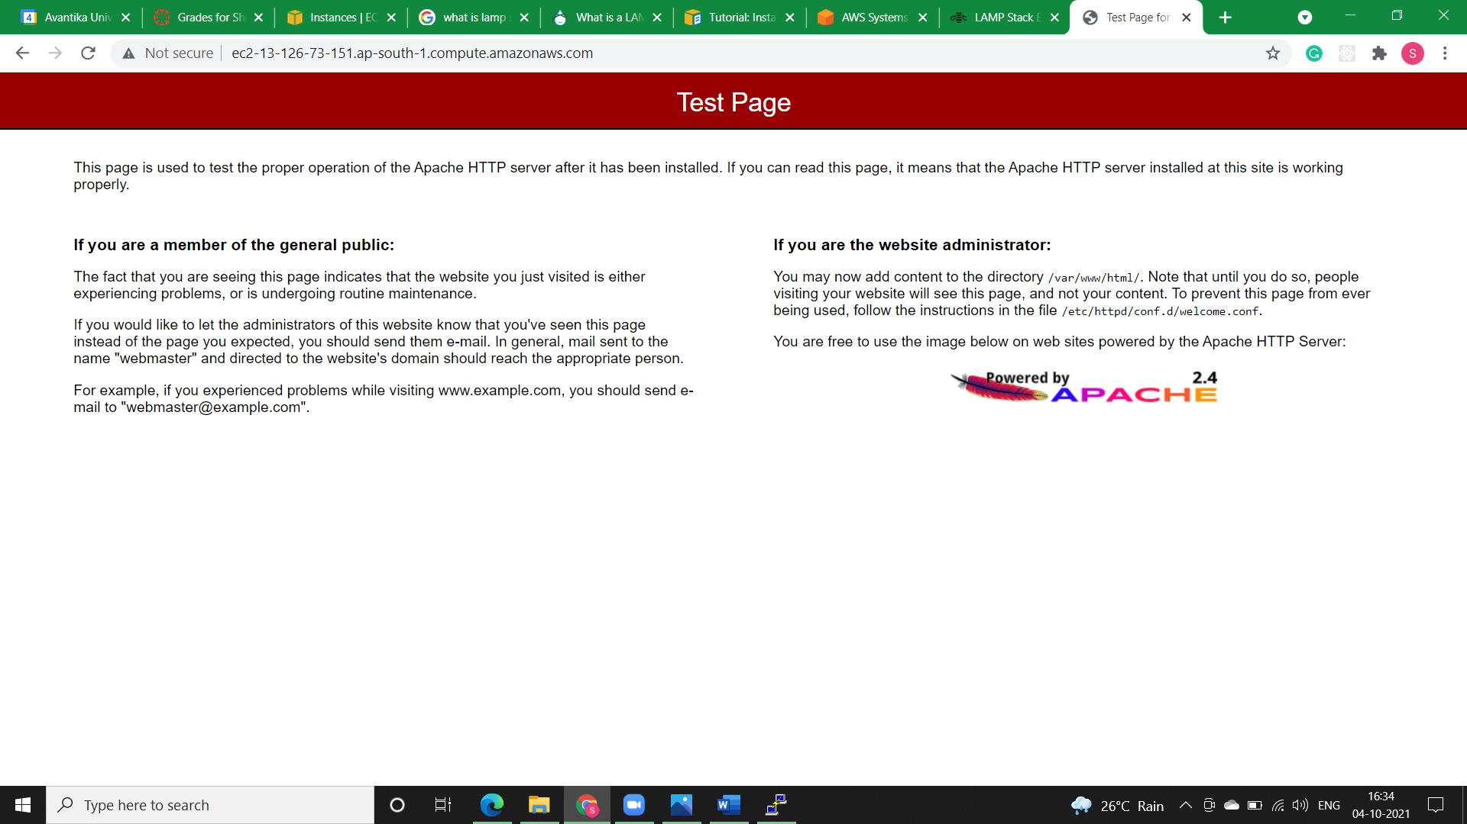

**Step10)** Apache *httpd* serves files that are kept in a directory called the Apache document root. The Amazon Linux Apache document root is /var/www/html, which by default is owned by root.

To allow the ec2-user account to manipulate files in this directory, we must modify the ownership and permissions of the directory. There are many ways to accomplish this task. We add ec2-user to the apache group, to give the apache group ownership of the /var/www directory and assign write permissions to the group.

**Step11)** Change the group ownership of /var/www and its contents to the apache group.

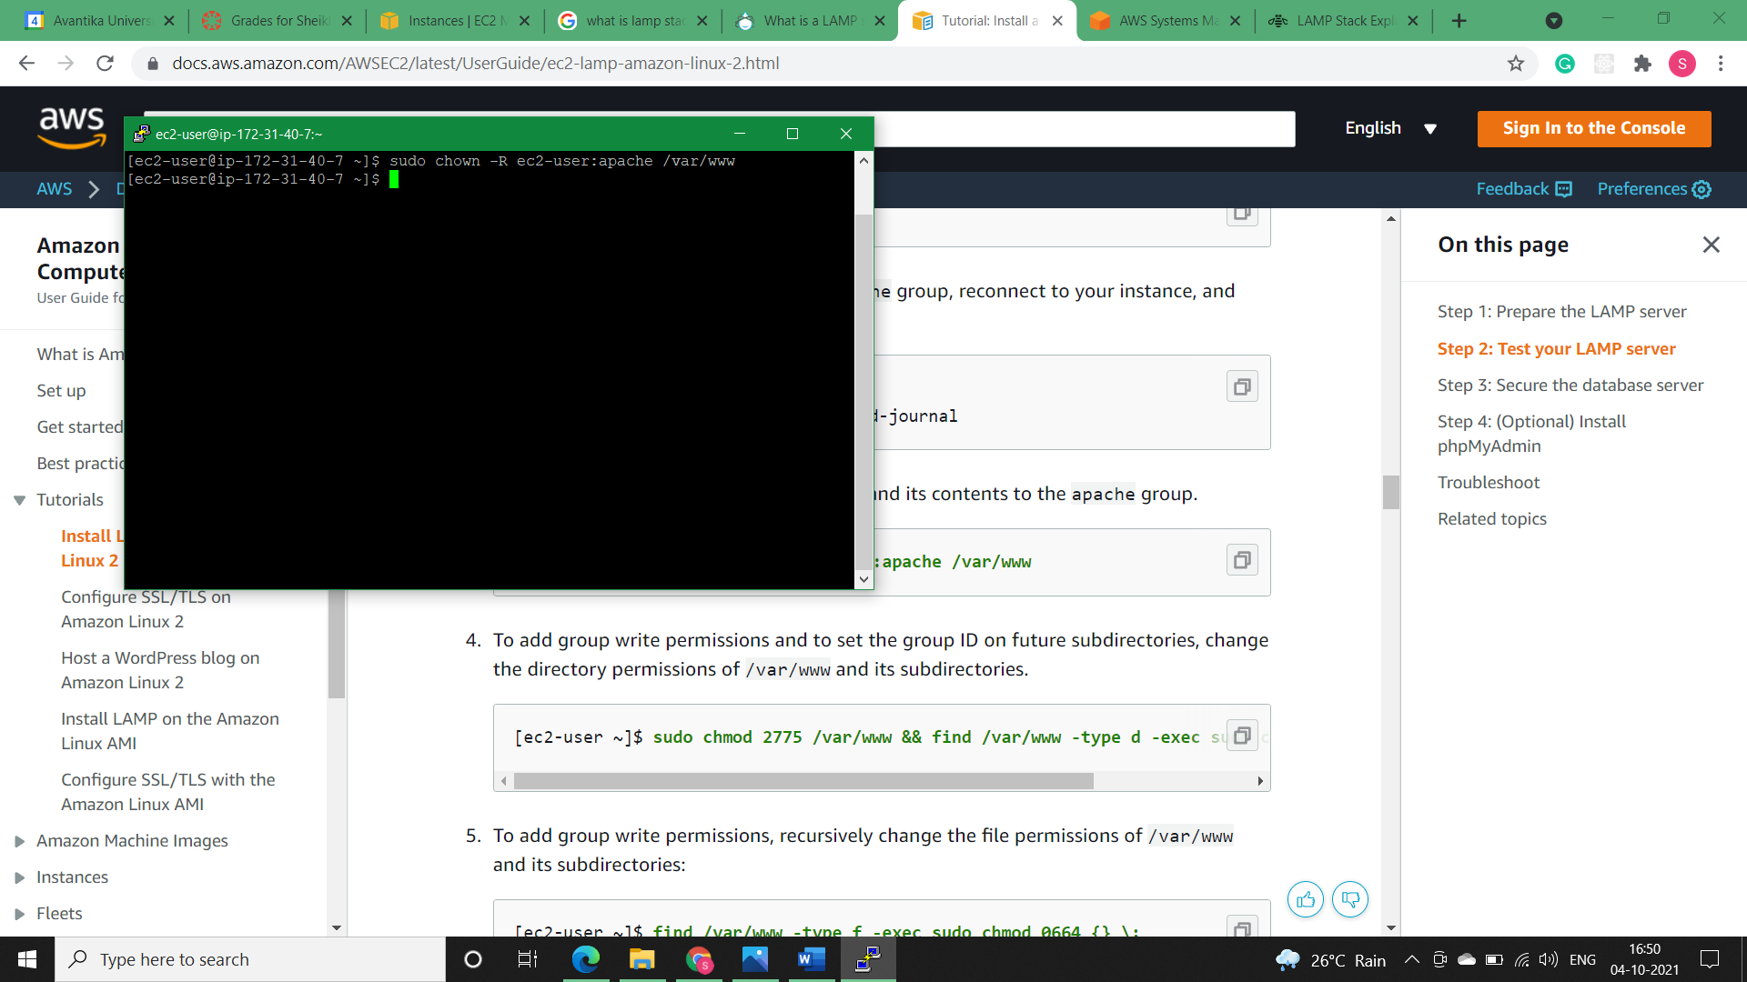

**Step12)** To add group write permissions and to set the group ID on future subdirectories, change the directory permissions of /var/www and its subdirectories.



**Step13)** To add group write permissions, recursively change the file permissions of /var/www and its subdirectories:

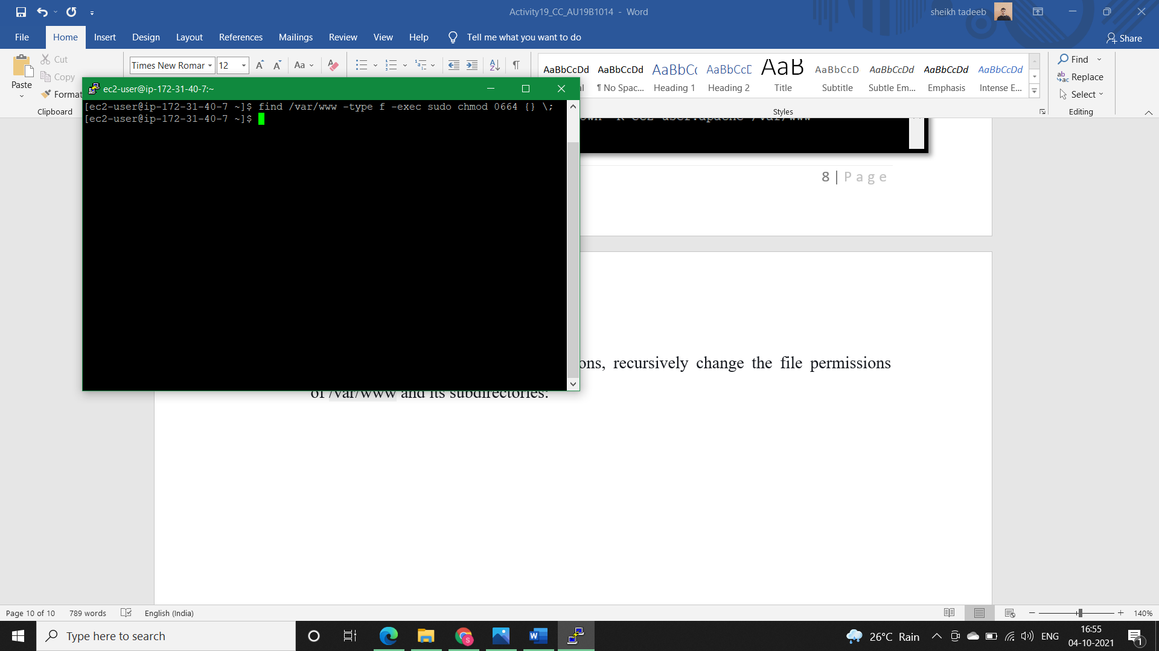

* **Testing the LAMP server:**

**Step1)** Create a PHP file in the Apache document root.

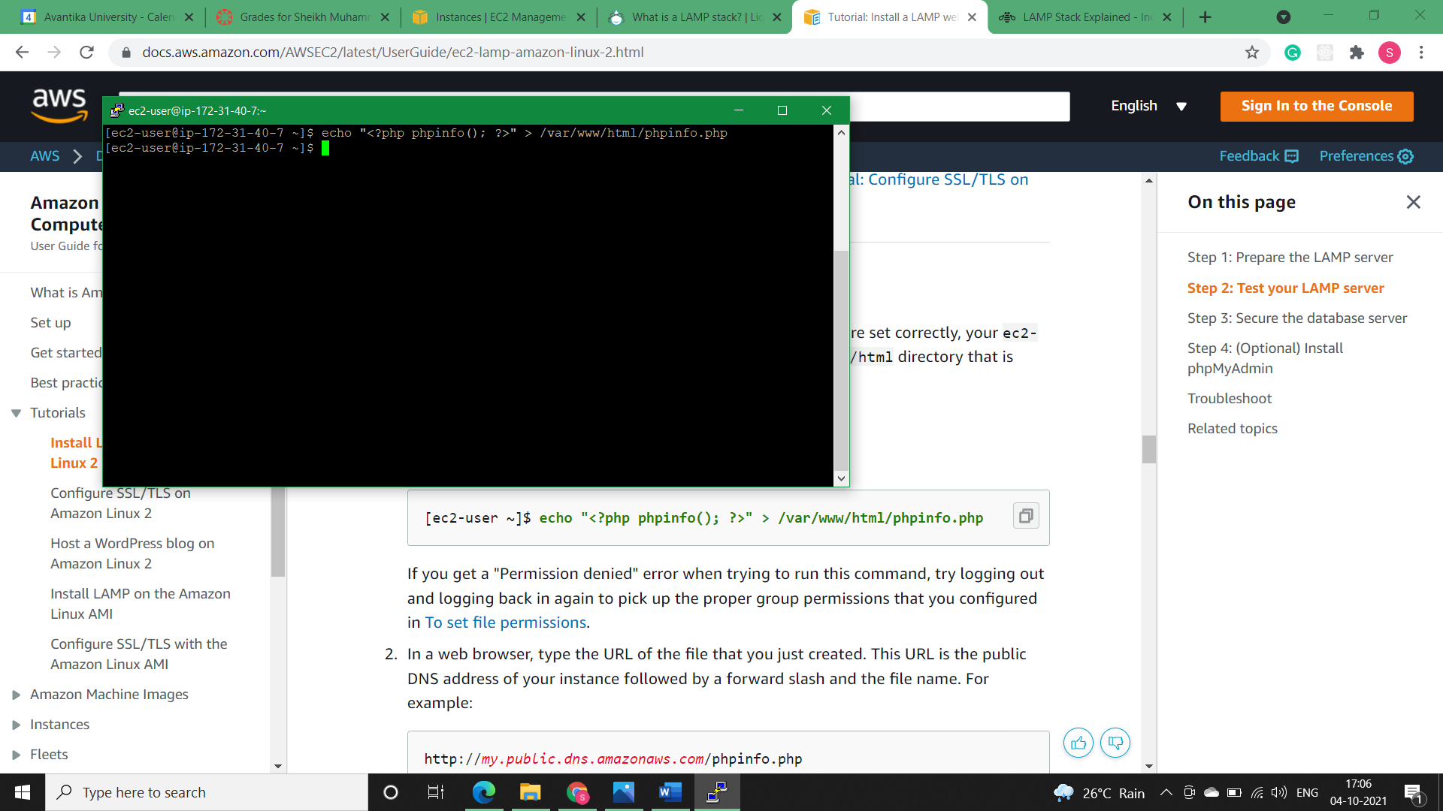

**Step2)** In a web browser, type the URL of the file that we just created. This URL is the public DNS address of our instance followed by a forward slash and the file name.

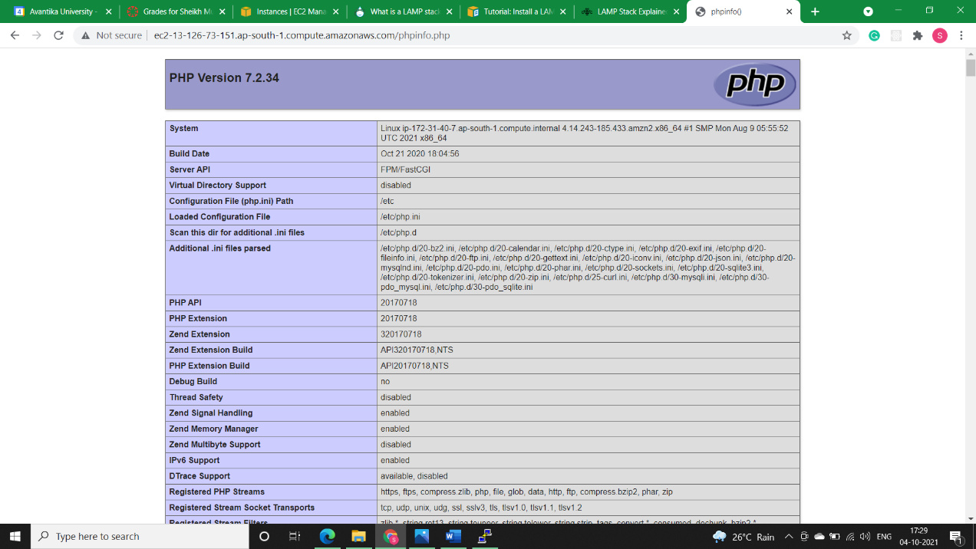

**Step3)** Delete the phpinfo.php file. Although this can be useful information, it should not be broadcast to the internet for security reasons.

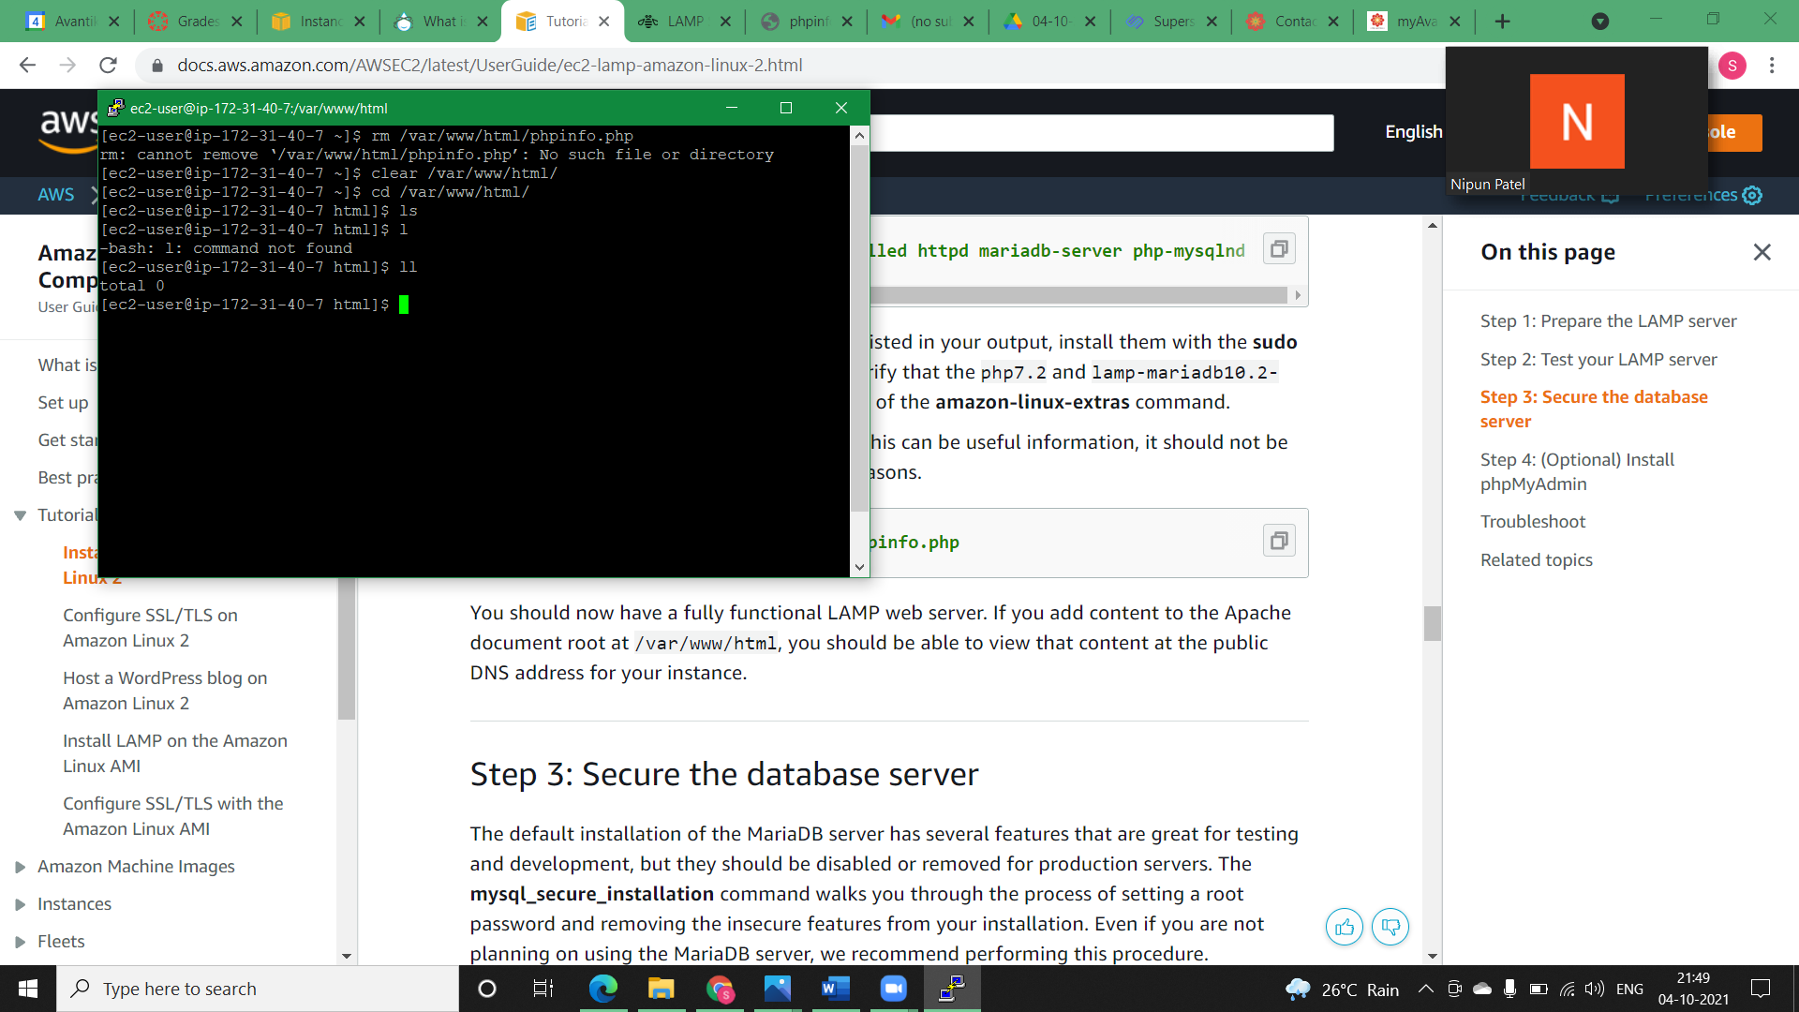

* **Securing the database server:**

**Step1)** Start the MariaDB server.

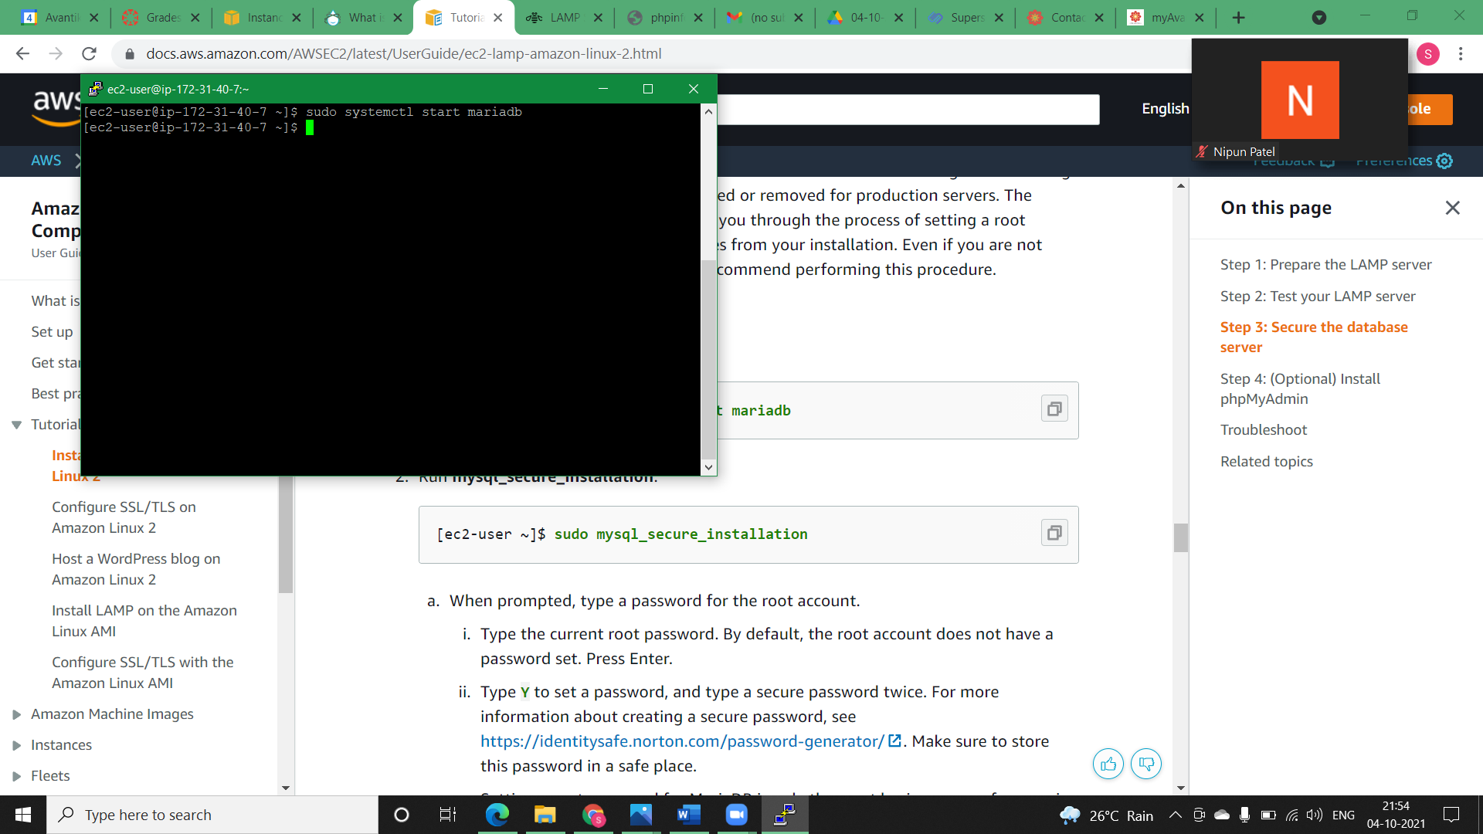

**Step2)** Run *mysql_secure_installation.*

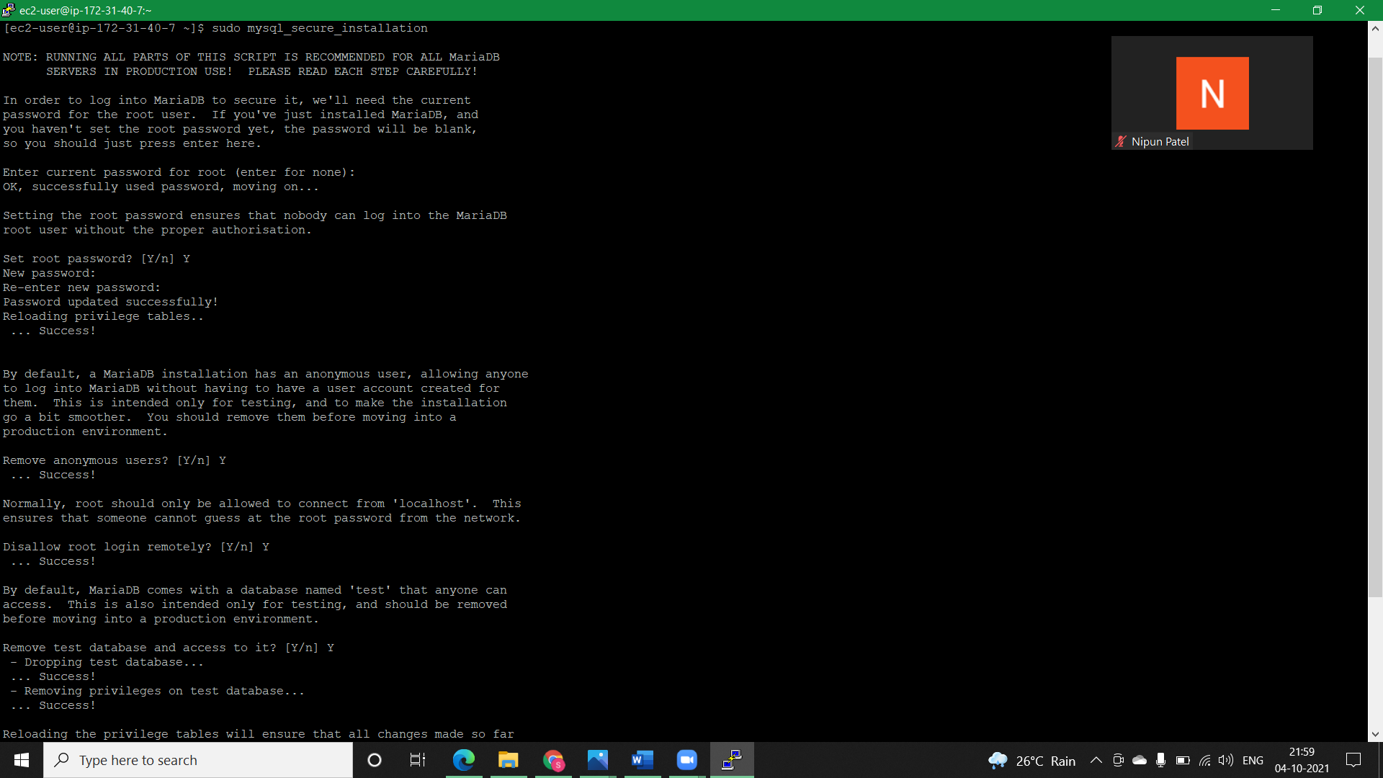

**Step2.1)** Type the current root password. By default, the root account does not have a password set. Press Enter.



**Step2.2)** Type Y to set a password, and type a secure password twice.

**Step2.3)**

Type **Y** to remove the anonymous user accounts.

Type **Y** to disable the remote root login.

Type **Y** to remove the test database.

Type **Y** to reload the privilege tables and save your changes.



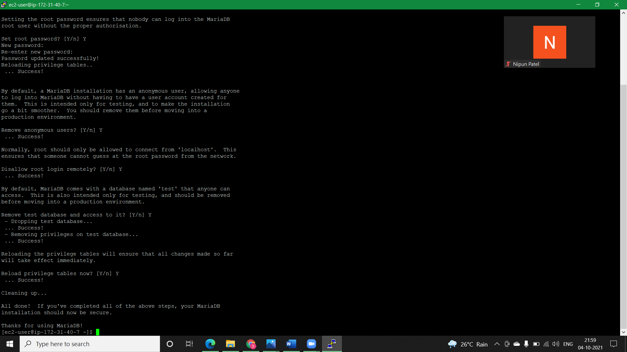

* **Install phpMyAdmin:**

**Step1)** Install the required dependencies.

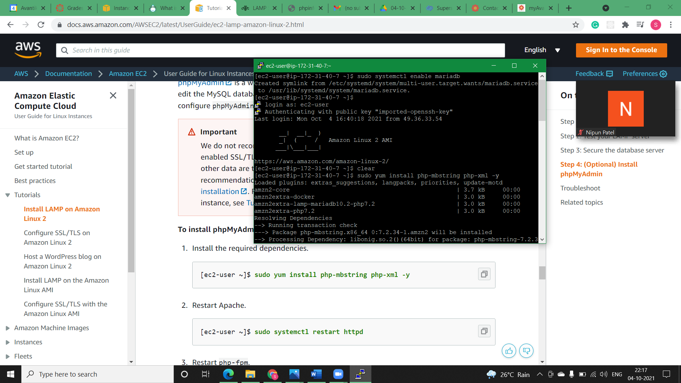

**Step2)** Restart Apache.

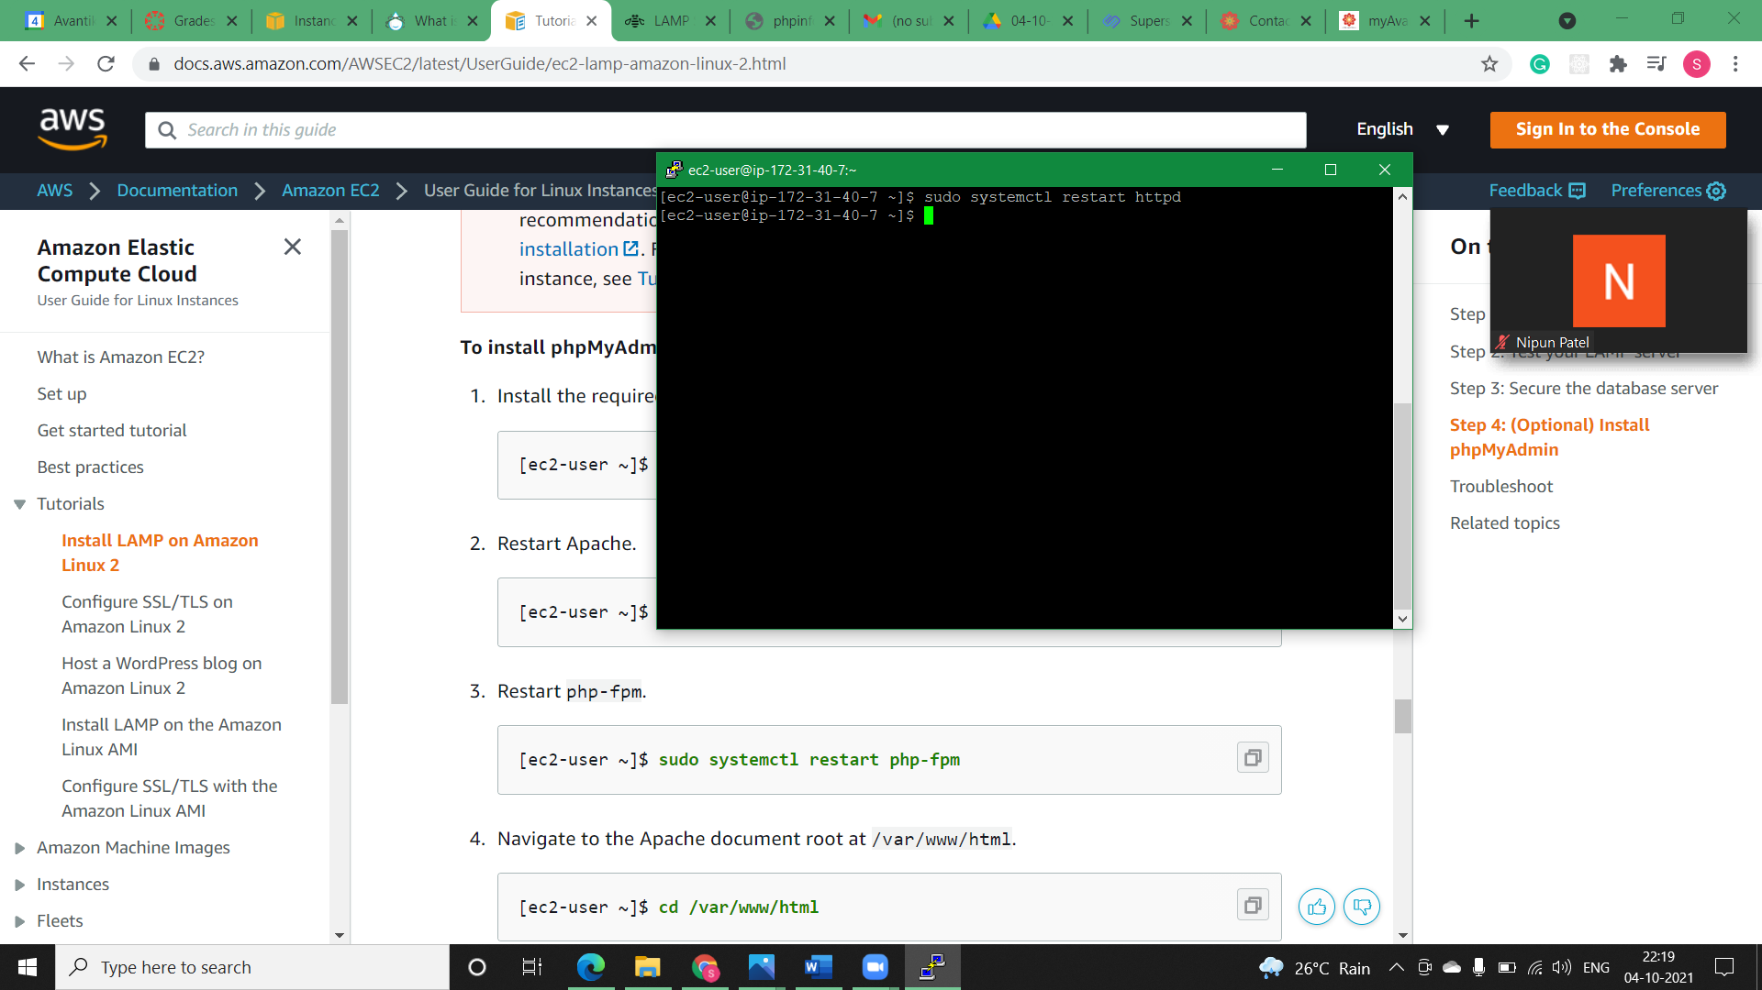

**Step3)** Restart php-fpm.

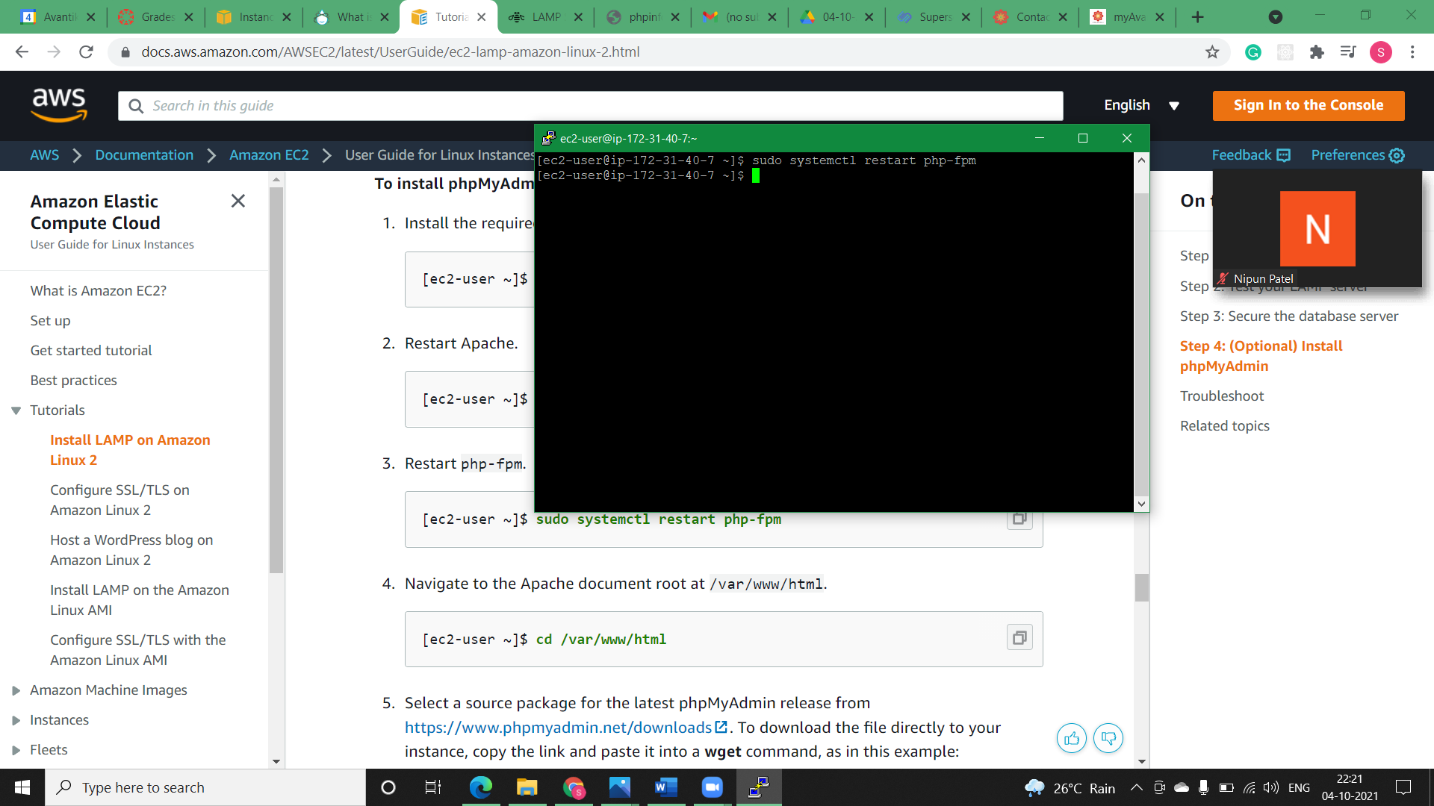

**Step4)** Navigate to the Apache document root at /var/www/html.

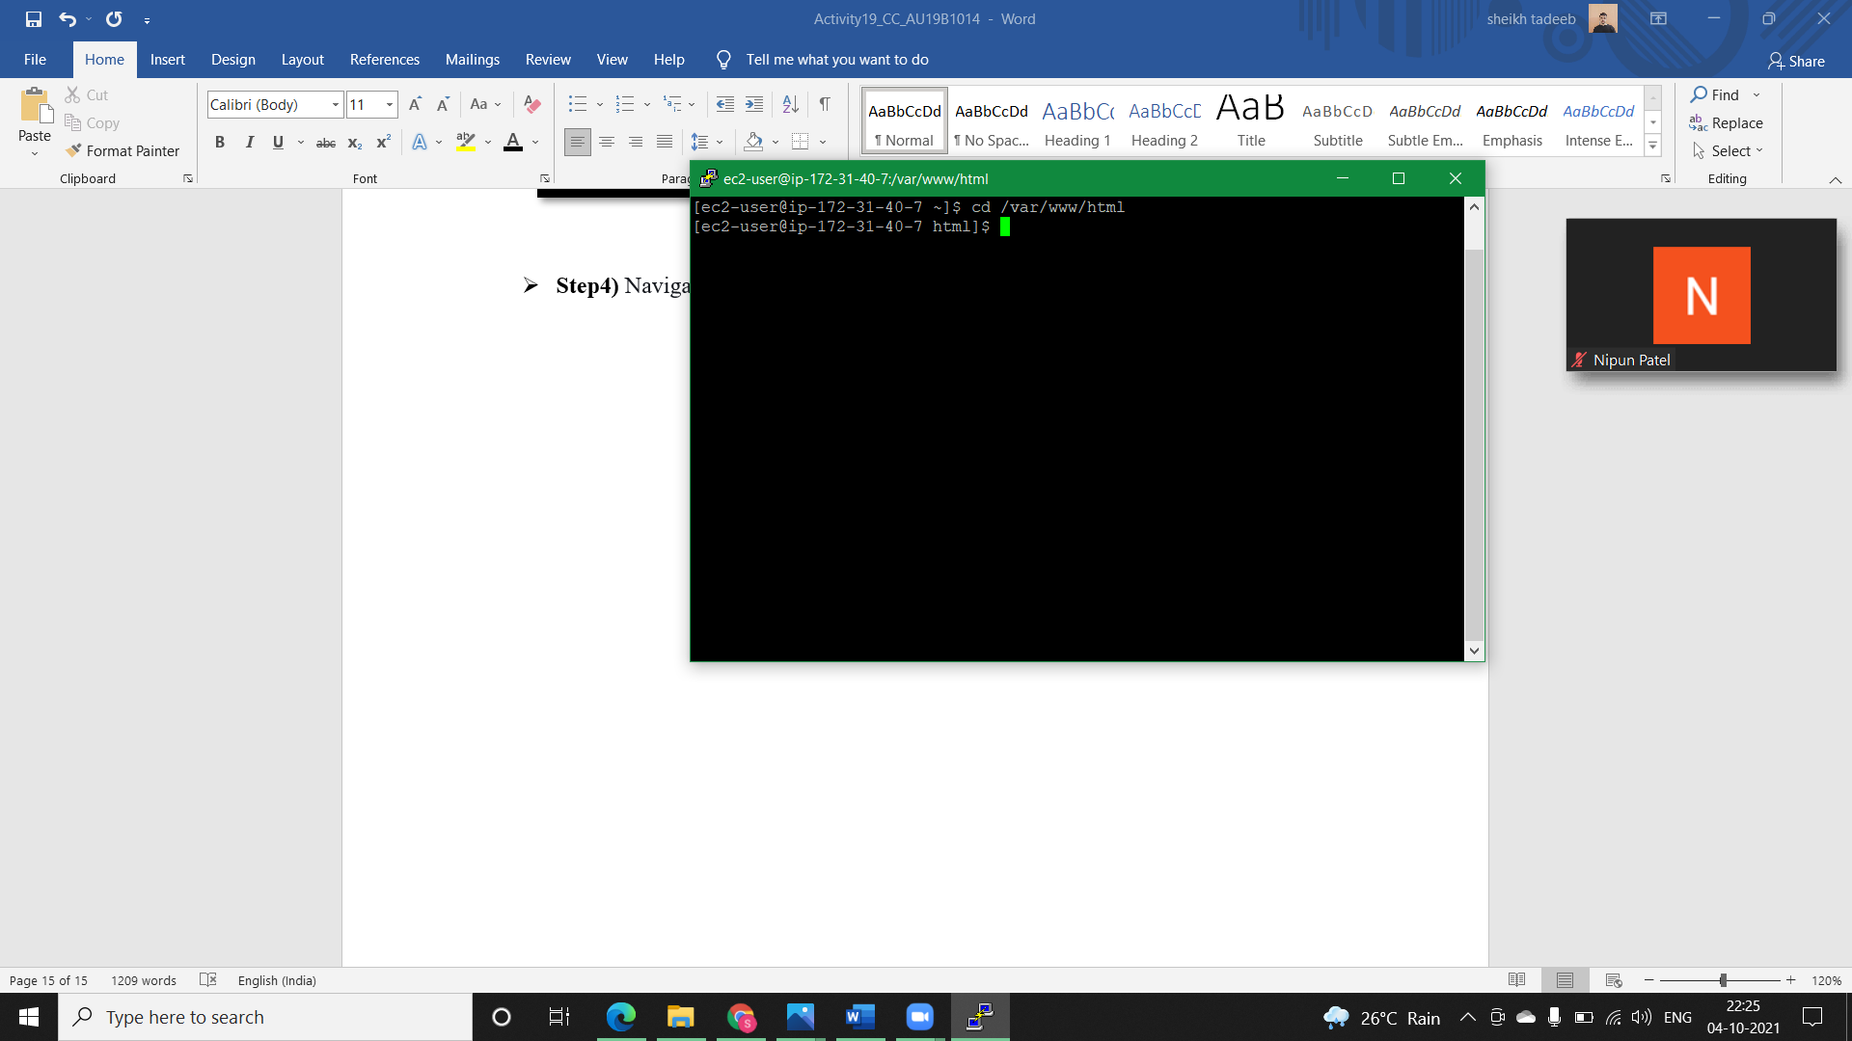

**Step5)** Select a source package for the latest phpMyAdmin release from <https://www.phpmyadmin.net/downloads>. To download the file directly to your instance, copy the link and paste it into a **wget** command, as in this example:

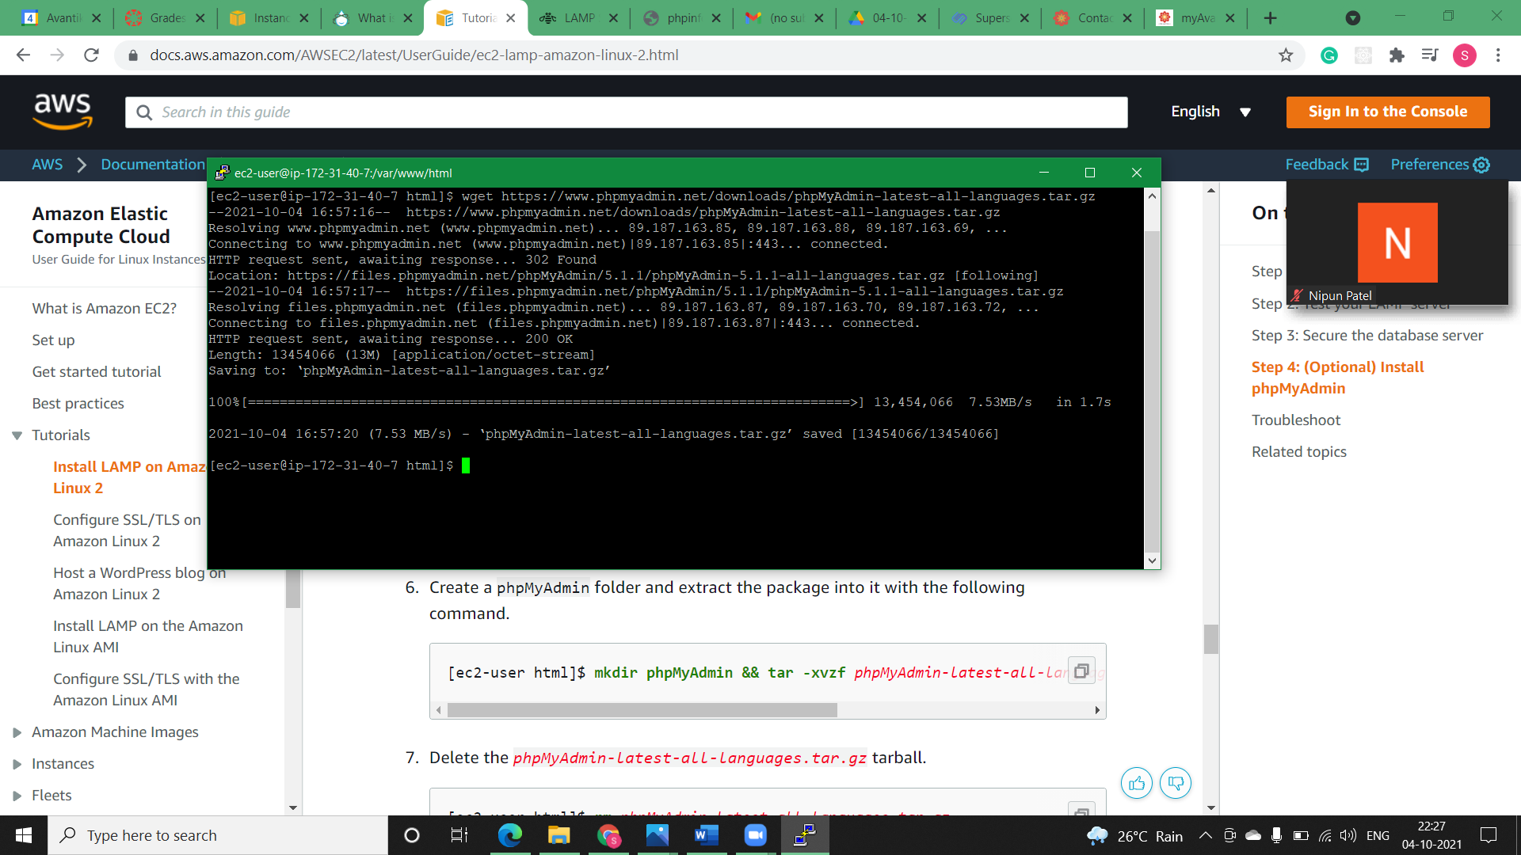

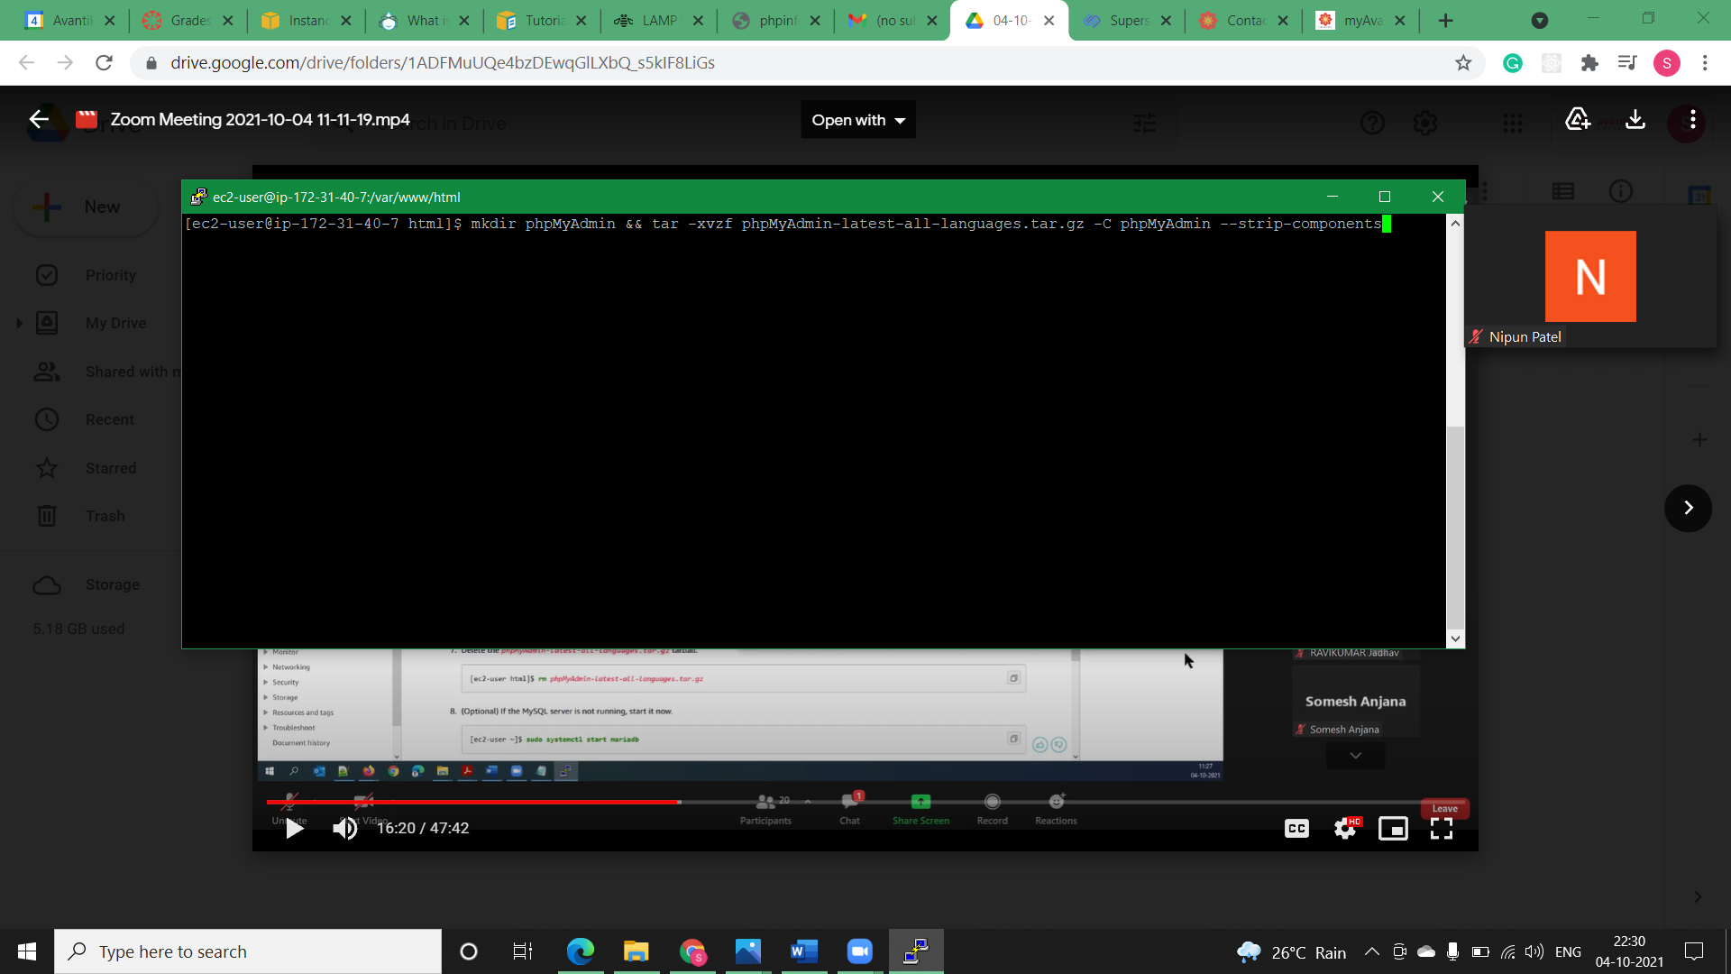**Step6)** Create a phpMyAdmin folder and extract the package into it with the following command.

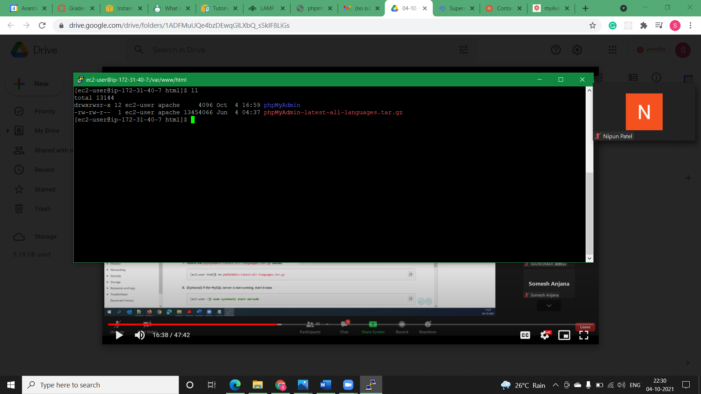

**Step7)** Delete the *phpMyAdmin-latest-all-languages.tar.gz* tarball.

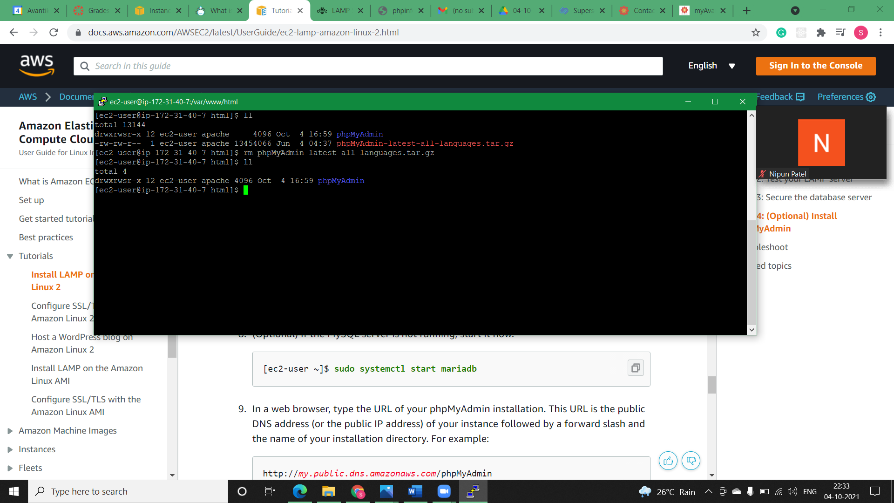

**Step8)** In a web browser, type the URL of our phpMyAdmin installation. This URL is the public DNS address (or the public IP address) of our instance followed by a forward slash and the name of our installation directory. i.e.,

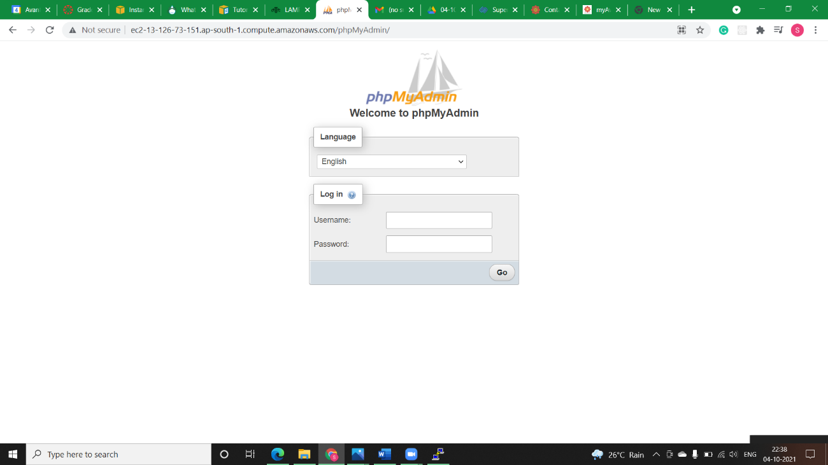

**Step9)** Log in to your phpMyAdmin installation with the root user name and the MySQL root password you created earlier.

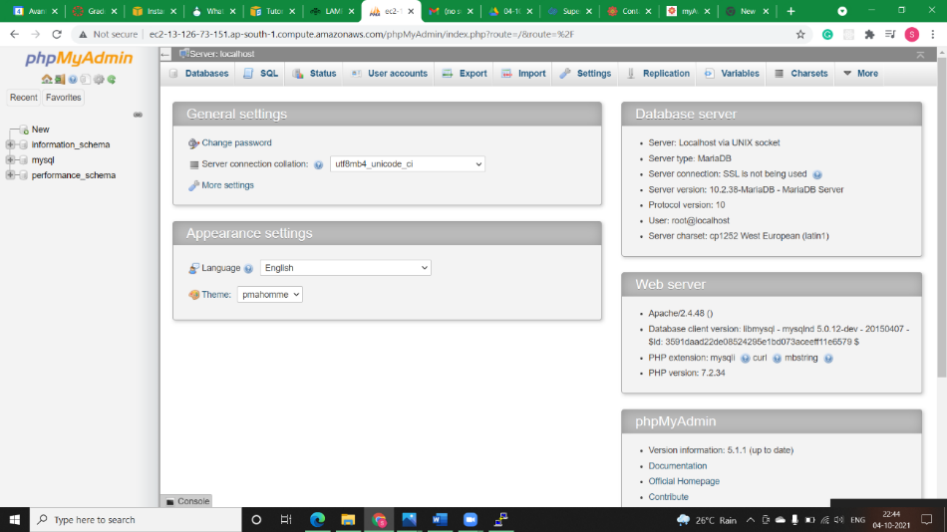

* **Configure SSL/TLS:**

**Step1)** To enable TLS on our server we would Connect to your instance and confirm that Apache is running.

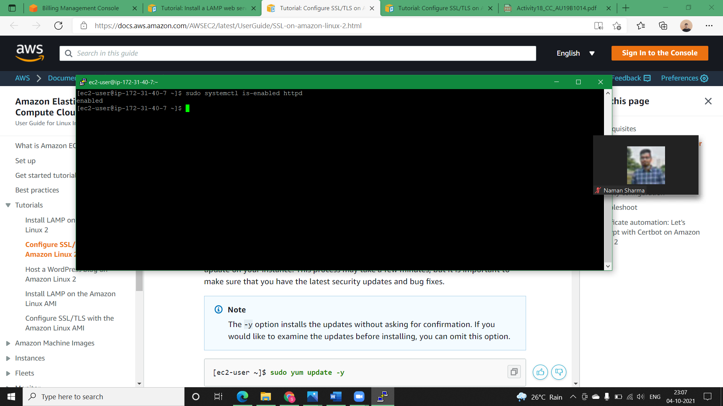

**Step2)** To ensure that all of your software packages are up to date, perform a quick software update on your instance. The -y option installs the updates without asking for confirmation.

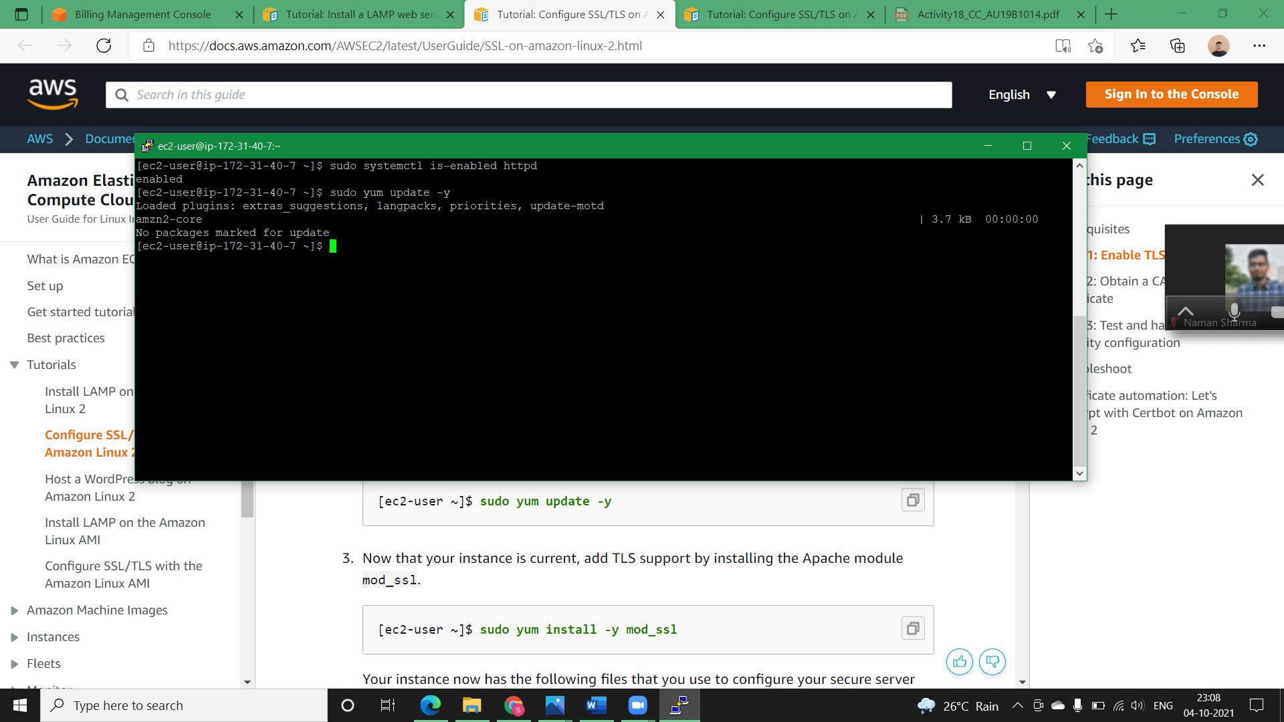

**Step3)** Now that your instance is current, add TLS support by installing the Apache module mod_ssl.

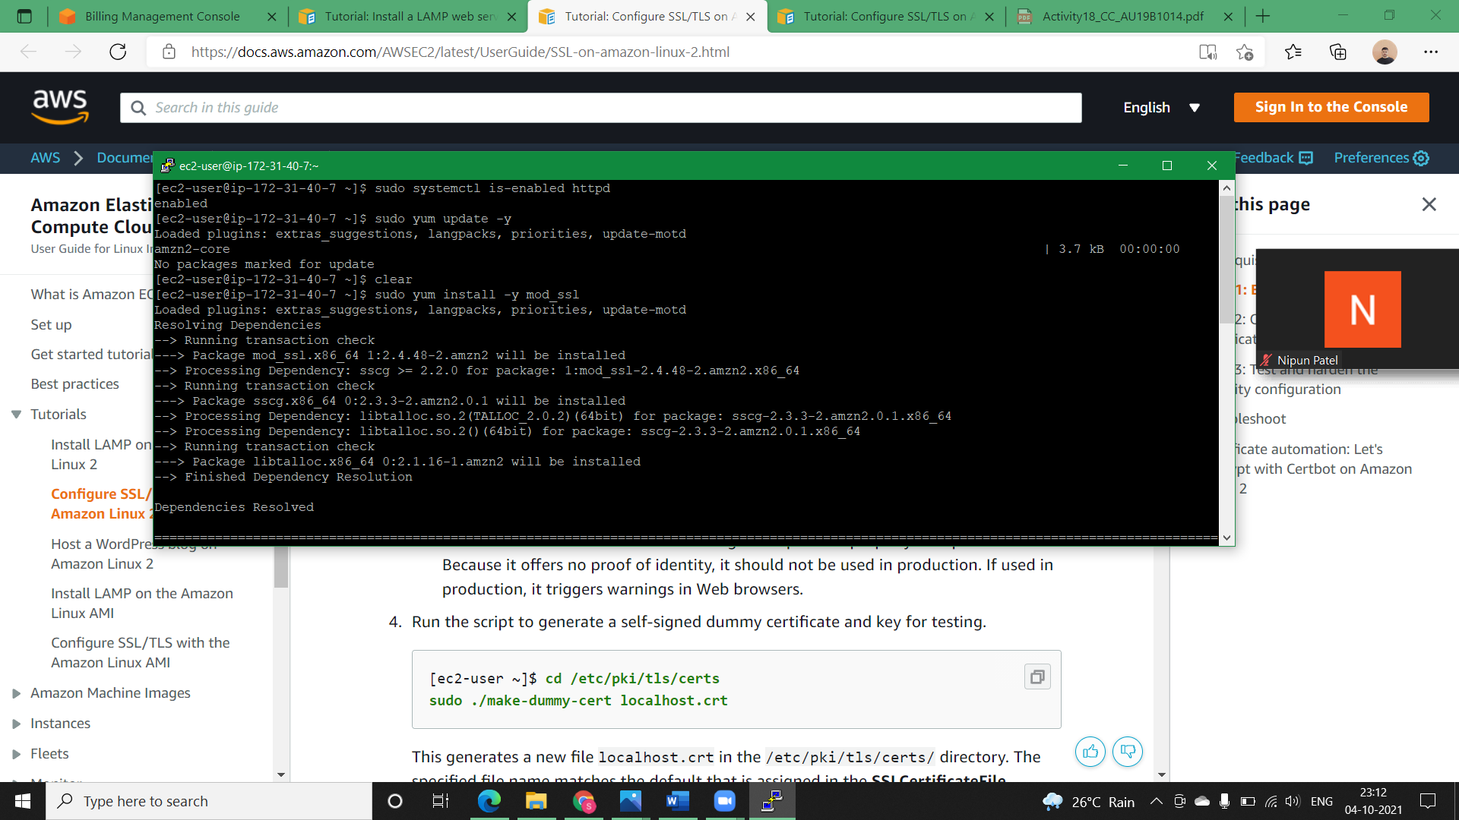

**Step4)** Run the script to generate a self-signed dummy certificate and key for testing.

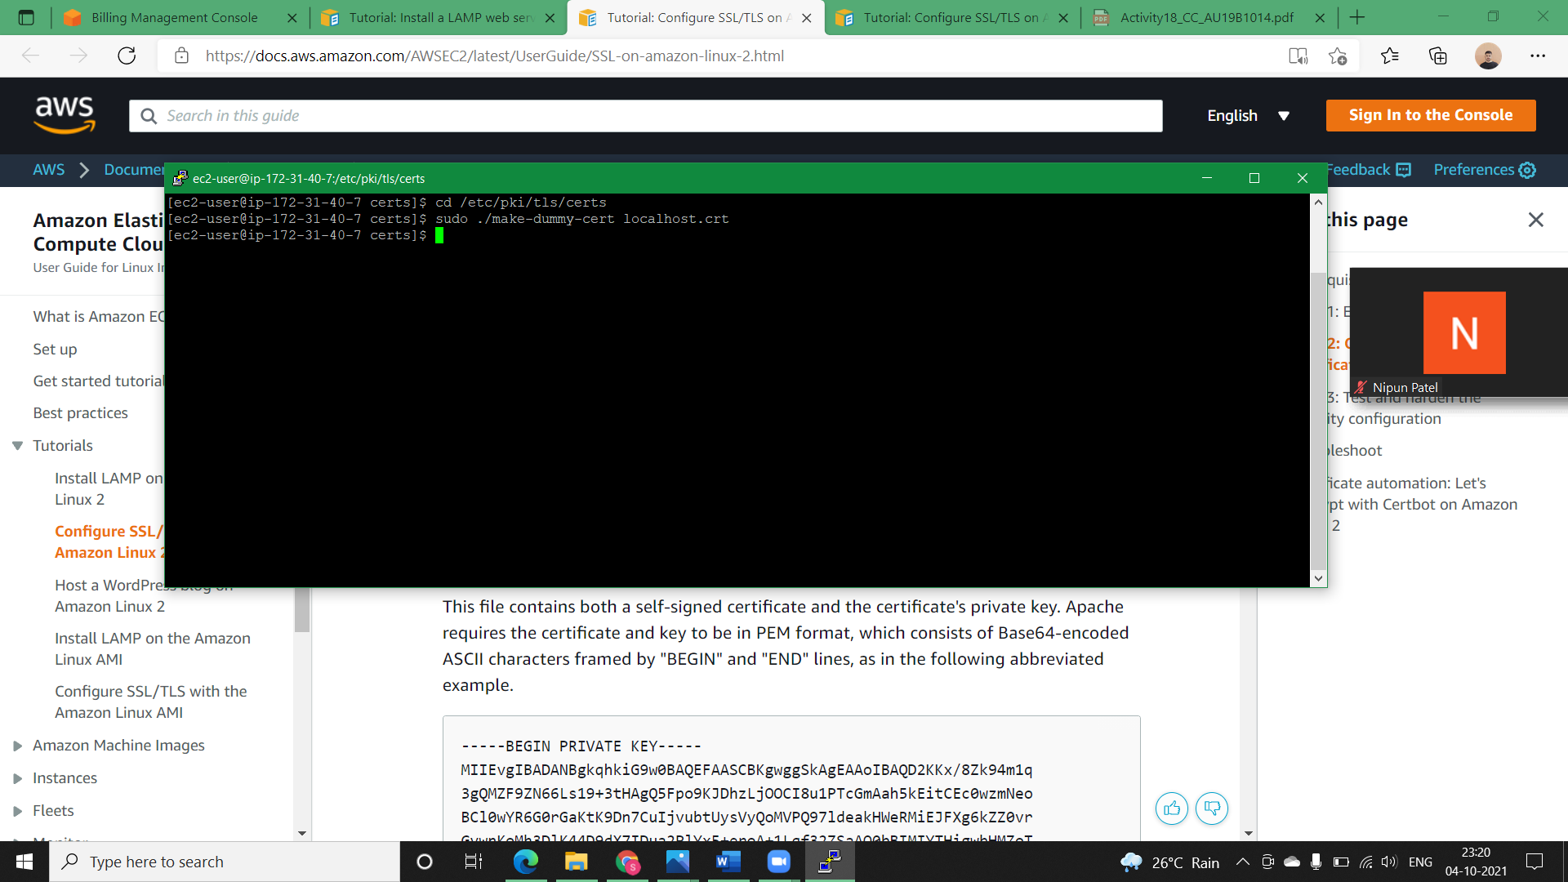

**Step5)** Open the /etc/httpd/conf.d/ssl.conf file using your favorite text editor (such as **vim** or **nano**) and comment out the following line, because the self-signed dummy certificate also contains the key. If you do not comment out this line before you complete the next step, the Apache service fails to start.

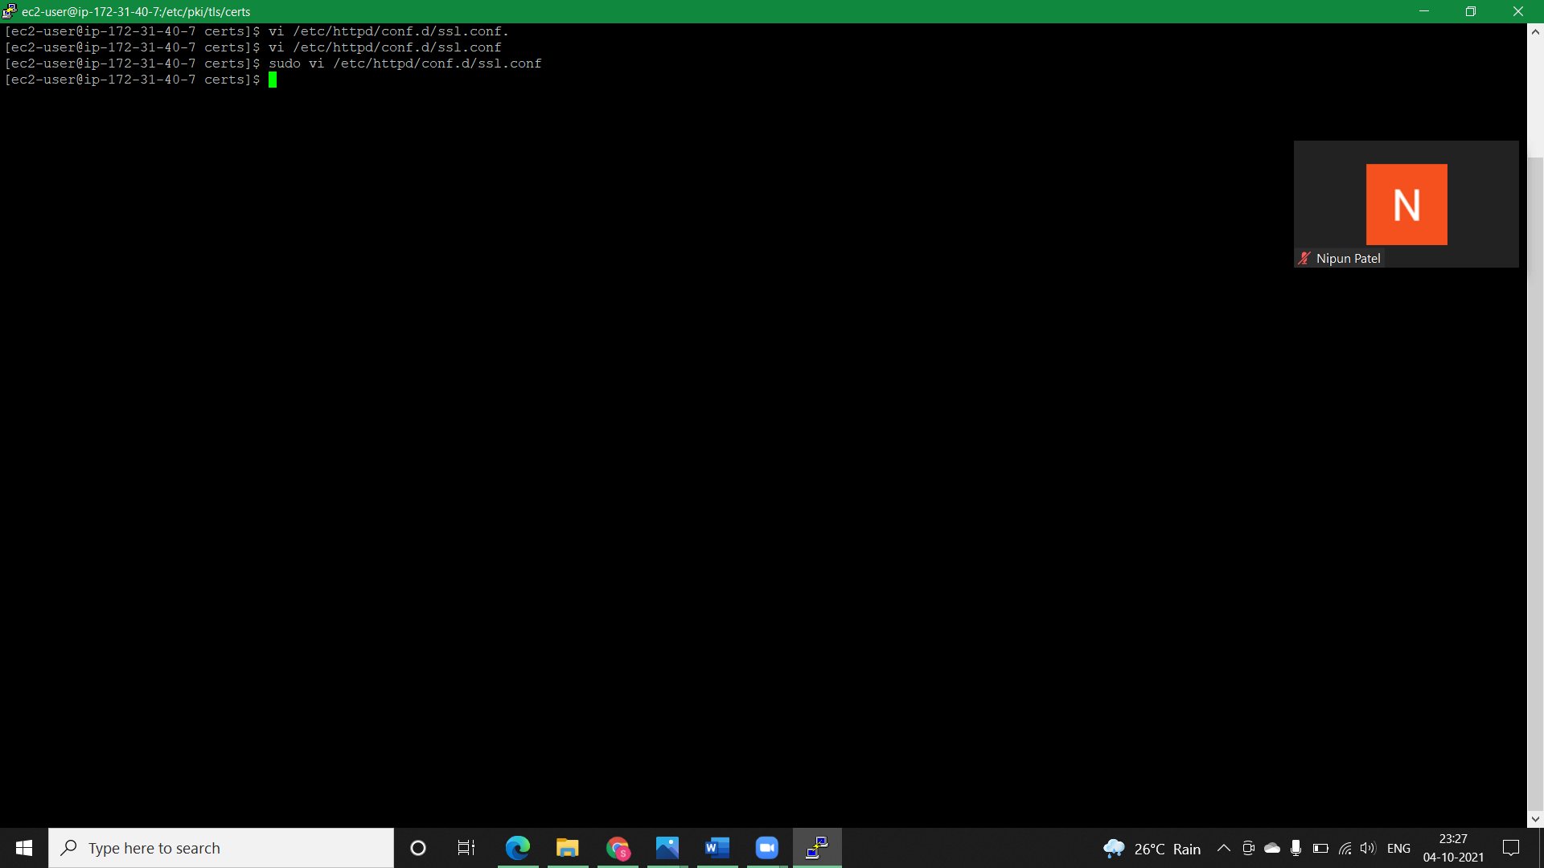

**Step6)** Restart Apache.

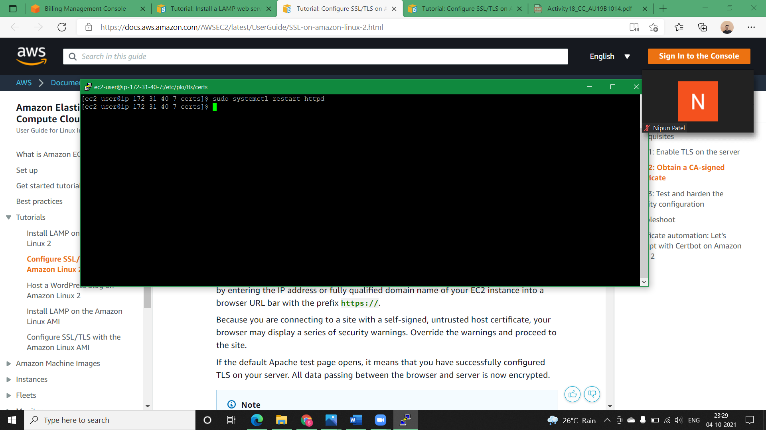

**NOTE: Check the test page to reconfirm whether its working or not.**